SIMATS ENGINEERING
Department of Computer Science and Engineering
CSA37 – Software Testing
ASSIGNMENT 3 – CO3
Analyze, Compare and Justify Unit, Integration, System, Regression and Acceptance Testing Strategies for a Hotel Reservation System
CO3: Analyze unit, integration, system, regression and acceptance testing for validating software systems.
Student Name | Vijayalakshmi G | Register Number | 192321080
Department / Section | IT | Academic Year | 2023–2027
Faculty Name | Gnanajeyaraman | Nature of Assignment | Individual
Duration | 1 Week | Total Marks | 50
Date of Submission | 03/11/2026 | Date of Evaluation

MARK SHEET (Rubric-based Evaluation)
Task | Task Title | Max Marks
1 | Unit Test Planning Analysis | 4
2 | Unit Test Design Analysis | 4
3 | Test Harness Analysis | 4
4 | Integration Strategy Analysis | 5
5 | Integration Test Planning Analysis | 5
6 | System Testing Analysis | 5
7 | Regression Testing Analysis | 5
8 | Alpha, Beta and Acceptance Analysis | 4
9 | Implementation and Performance Evaluation | 6
10 | Test Strategy Adaptation Challenge | 8
TOTAL |  | 50

OVERALL REMARKS

Student Signature | Faculty Signature | Program Director
MANDATORY SUBMISSION EVIDENCE CHECK
✓ = present ✗ = missing / not satisfied P = partly present. Checked by me against the “Evidence Expected” of each task.
Task | Evidence expected | Status | Where in this submission
1 | A unit test plan, a faults-found/coverage/effort table for the three approaches, and a justified approach with its exit criterion. | ✓ | Tables 1–3; Figure 1
2 | Unit test sets for three styles, a faults-found and coverage table, a maintainability comparison, and a justified standard. | ✓ | Tables 6–8
3 | Three working harnesses with the same 10 tests, a setup-effort table, a note on hidden defects, and a justified choice. | ✓ | Tables 9–12
4 | A dependency graph, stub/driver counts, a fault-exposure table for the three strategies, and a justified integration order. | ✓ | Figure 2; Tables 13–15
5 | An integration test plan, an interface coverage matrix, a risk-exposure table, and a justified plan with exit criteria. | ✓ | Tables 16–19; Figure 4
6 | Selenium scenario results, a JMeter response-time and error table, a compatibility matrix, and a justified allocation of system test effort. | P | Tables 20, 21, 23, 24; Figures 5–7
7 | A selection table for three strategies, a regression-fault detection table, time calculations, and justified recommendations for daily and release builds. | ✓ | Tables 25, 26, 27; Figure 8
8 | Ten acceptance test cases with results, alpha/beta plans, a feedback classification table, and a justified acceptance decision rule. | ✓ | Tables 28–31; Figure 9
9 | A measured comparison of three strategies, an original block diagram and decision table, an applications transfer table, and a defended final strategy. | ✓ | Tables 33, 34, 35, 37; Figures 10, 11
10 | Three adaptation strategies applied and compared with measured and calculated evidence, and a RETAIN / MODIFY / REDESIGN decision that follows logically from the changed constraints. | ✓ | Tables 40–44; Figures 12, 13

MULTI-LEVEL TESTING EVIDENCE CHAIN (Tasks 1–10)
Evidence item | Status | Observation
Unit faults, coverage and effort per approach | ✓ | Task 1 tables
Harness results and hidden-defect demonstration | ✓ | Task 3
Interface-fault exposure per integration strategy | ✓ | Task 4 table and figure
Risk exposure and the payment-confirmed / room-not-confirmed test | ✓ | Task 5
End-to-end, load, security and compatibility results (measured) | ✓ | Task 6
Regression selection, time and fault detection | ✓ | Task 7
Acceptance tests executed and decision rule | ✓ | Task 8
Adaptation to microservices (measured) | ✓ | Task 10

SUBMISSION CHECKLIST (not separately marked)
Requirement | Status
All 10 tasks answered | ☒ Yes ☐ Partly ☐ No
Every technique applied, compared and a choice justified in each task | ☒ Yes ☐ Partly ☐ No
Unit, integration and system tests executed on my own prototype and staging app | ☒ Yes ☐ Partly ☐ No
Calculations (risk exposure, run times, scaling) shown step by step | ☒ Yes ☐ Partly ☐ No
Test plans with entry and exit criteria included | ☒ Yes ☐ Partly ☐ No
Load-test, compatibility and security results recorded | ☒ Yes ☐ Partly ☐ No
Tables, figures and diagrams included and readable | ☒ Yes ☐ Partly ☐ No
Cross-references and table / figure numbering correct | ☒ Yes ☐ Partly ☐ No
Work consistent throughout | ☒ Yes ☐ Partly ☐ No
No unfilled template placeholders | ☒ Yes ☐ Partly ☐ No

SOFTWARE TESTING
ASSIGNMENT 3 – SUBMISSION
Vijayalakshmi G | Register No. 192321080 | IT | Academic Year 2023–2027 | Faculty: Gnanajeyaraman
CO3: Analyze unit, integration, system, regression and acceptance testing for validating software systems.
Assignment Title: Analyze, Compare and Justify Unit, Integration, System, Regression and Acceptance Testing Strategies for a Hotel Reservation System (Total Marks – 50)
Duration: 1 week

Scenario – “StayEasy” Hotel Reservation System before the December Peak Season
Seaview Residency, a 120-room hotel in Mahabalipuram, is replacing its phone-and-register booking with StayEasy, a web system for room search, booking, payment, billing with GST, loyalty points and SMS/e-mail notification. In a trial week, a guest was billed for 3 nights while the booking showed 2, a cancelled booking still blocked a room, a payment confirmation was received but the room was not confirmed, and the site slowed down when 60 guests searched together. The hotel must go live before the 15 December peak season and wants confidence at every level of testing, from single functions to hotel-staff acceptance.
You are the test lead. In every task, three candidate techniques are given. You must apply all three, analyze them, compare them, choose one, and justify your choice with evidence. The following operating data is given (state and justify any additional assumption you make):
Parameter | Value
Architecture | Six modules: Search and Availability (S), Booking (B), Payment (P, uses an external payment gateway), Billing and Invoice (I), Loyalty (L), Notification (N, uses an SMS gateway). Calls: S→B, B→P, P→I, I→L, B→N, P→N
Room tariff | Standard ₹3,000, Deluxe ₹4,500, Suite ₹8,000 per night; season factor: peak (15 Dec – 5 Jan) × 1.4, normal × 1.0, off-season × 0.8
Booking rules | 1 to 30 nights; booking up to 365 days ahead; at most 4 guests per room; check-in 2 pm, check-out 11 am
Tax and cancellation | GST 12% on a tariff up to ₹7,500 per night, 18% above; free cancellation until 48 hours before check-in, 50% charge within 48 hours, 100% for no-show
Loyalty | 1 point per ₹100 spent; 100 points redeem for ₹50; redemption at most 20% of the bill
Quality targets | Response time ≤ 2 s at 500 concurrent users; availability 99.5%; no double booking of a room; payment and room status must always agree
Test window and team | 4 weeks; 2 testers, 3 developers, 1 front-desk representative; test, staging and production-like UAT environments
Test assets | 800 existing test cases (manual) with a module traceability sheet, a staging copy of 2 years of anonymised booking data, a sandbox payment gateway
Tools | Python with pytest and unittest.mock (or Java with JUnit and Mockito), Selenium WebDriver, Apache JMeter, Postman, a defect tracker
Users for trials | 3 travel agents and 5 hotel staff (alpha), 40 loyalty-programme guests (beta), the hotel manager (final acceptance)

HOW THIS SUBMISSION IS ORGANISED
Every task repeats the question and then gives my Ans:, answering the bullets in order. stayeasy.py holds the units and modules with seeded faults, regress.py the GST-change regression prototype, app.py the staging web application; run3a.py, run3b.py and run3c.py run the experiments and write results3a/b/c.json, the source of every measured figure.
- Tool substitutions. Selenium WebDriver and Apache JMeter were not available in the sandbox I worked in, and only Chromium could be launched. Browser scenarios were automated with Playwright (Chromium desktop and a Pixel 5 phone profile); load and stress tests used my Python load generator, which follows a JMeter thread-group plan (ramp-up, think time, samplers, summary). Branch coverage was measured with my sys.settrace tracer in place of coverage.py. Firefox and Safari runs remain to be done on a real machine (Task 6 marked P).
- Effort figures (hours, minutes) are estimates and are labelled so; faults found, coverage, response times and run times are measured.
- Load and stress runs were shortened (30–40 s steady state instead of 10 minutes) to fit my environment; the ramp-up and user counts are as required.

TASK 1 – Unit Testing and Unit Test Planning: Compare Unit Test Planning Approaches [4 Marks]
Developers write unit tests whenever they have time. The test lead needs a unit-test approach for the functions calculate_room_charge(room, nights, season) and cancellation_fee(hours_before, charge). Compare three approaches.
Technique | Basic idea and key concepts / tools
A. Tests written after coding | Each developer adds a few tests once the unit works, with no plan.
B. Plan-first unit testing | A unit test plan (units, features, approach, pass/fail criteria, schedule, tools) is written before coding and tests are executed against it.
C. Test-driven development (TDD) | A failing test is written first, then code is written to pass it, then refactored.

- Prepare a unit test plan for the two functions: units to be tested, features, approach (black-box and white-box), test data, entry and exit criteria, tools, effort estimate and schedule.
- Implement the two functions with four seeded faults (for example, peak factor applied to off-season, 49-hour boundary, wrong GST slab, rounding), apply A, B and C, and record the faults found, coverage and effort.
- Analyze the three approaches on defects found at unit level, branch coverage achieved, rework after change, and the quality of the resulting design.
- Examine which kinds of unit faults (boundary, rounding, wrong rule) each approach left in the code and the reason.
- Evaluate the approach the team should follow for all StayEasy units and justify it with evidence; state the exit criterion for unit testing.
- Critique the use of an AI code assistant to write the unit tests: generate tests for cancellation_fee, check them against the cancellation rule and judge their trustworthiness.
Evidence Expected: A unit test plan, a faults-found/coverage/effort table for the three approaches, and a justified approach with its exit criterion.
Ans:
Planning Unit Tests for calculate_room_charge and cancellation_fee
1. Unit test plan
Table 1: Unit test plan (UTP-01)
Plan item | Content
Units | U-01 calculate_room_charge(room, nights, season) → charge incl. GST; U-02 cancellation_fee(hours_before, charge)
Features to test | Tariff per room type; season factor (peak × 1.4, normal × 1.0, off × 0.8); 1–30 nights; GST 12% / 18% on the per-night tariff after the season factor; free / 50% / 100% cancellation; rounding to paise (half up)
Features not tested here | Date-to-season mapping (Booking unit), payment, invoice layout
Approach | Black-box: equivalence classes (3 rooms × 3 seasons, valid/invalid nights, three cancellation windows) and boundaries (1, 30, 0, 31 nights; 48 h, 47.99 h, 0 h). White-box: every branch of both functions, measured with a branch tracer
Test data | Standard/Deluxe/Suite in all seasons; Suite off-season (₹6,400 → 12%) and normal (₹8,000 → 18%); charges with odd paise (₹3,333.33, ₹7,777.77)
Entry criteria | Function signatures and rules frozen; code compiles; plan reviewed by the test lead
Exit criteria | 100% of planned tests pass; ≥ 85% branch coverage per unit; no open Critical/Major unit defect; boundaries 48 h and 7,500 covered
Tools | pytest, unittest.mock, branch tracer (stools.Tracer – coverage.py could not be installed in my environment)
Effort and schedule | Plan 1 h; design 1.5 h; execution and fixing 0.5 h → 3 h, completed on day 2 of week 1, before integration starts
Responsibilities | Developer writes and runs; tester reviews the plan and the boundary list

2. Four seeded faults; A, B and C applied
Table 2: Seeded unit faults
ID | Seeded fault
U1 | Peak factor (× 1.4) applied to the off-season
U2 | Free cancellation only from 49 hours (48 h charged)
U3 | GST slab chosen on the base tariff, not on the seasonal tariff (Suite off-season taxed 18%)
U4 | Amounts truncated to the rupee instead of rounded to paise

Table 3: Faults found, branch coverage (room charge / cancellation) and effort (estimated)
Approach | Tests | U1 | U2 | U3 | U4 | Branch coverage | Effort
A Written after coding | 4 | ✗ | ✗ | ✗ | ✗ | 50% / 67% | 0.5 h
B Plan-first | 12 | ✓ | ✓ | ✓ | ✓ | 67% / 83% | 3.0 h
C TDD | 18 | ✓ | ✓ | ✓ | ✓ | 83% / 83% | 4.0 h

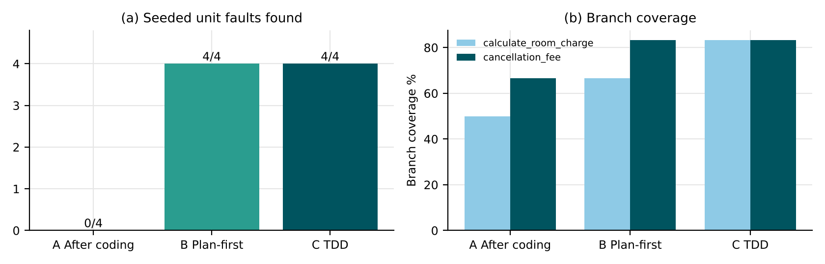
Figure 1: Unit faults found and branch coverage for the three approaches
A’s four “usual” tests (2 normal nights, 3 peak nights, 72 h and 10 h before check-in) passed on all four faulty versions: none of them is an off-season stay, a Suite out of season, a cancellation at exactly 48 h or an amount with odd paise. B and C found all four because the plan, and in TDD the first failing tests, were written from the rules – each rule produced its own test.
3. Comparison
Table 4: Comparison of the approaches
Criterion | A After coding | B Plan-first | C TDD
Unit defects found | 0/4 | 4/4 | 4/4
Branch coverage | 50% / 67% | 67% / 83% | 83% / 83%
Rework after the peak factor changes to 1.5 | 1 test | 1 test | 1 test – and the failing test showed the change at once
Design quality | Code shaped first; tests fit it | Inputs and outputs fixed before coding | Small functions; validation (unknown room, 0/31 nights) written because a test demanded it

4. Faults each approach left behind
A left all four: the boundary fault U2 (48 h), the rounding fault U4 (needs an amount with odd paise), and the two wrong-rule faults U1 and U3, which appear only for the off-season – a season the developer did not think to try. The reason is the same in each case: tests written after the code confirm what the developer had in mind while coding. B and C left none of the seeded faults, but they share a blind spot: both test the rule as written, so a wrong rule in the requirement (e.g. GST on the base rather than the seasonal tariff, if the requirement itself were ambiguous) would pass both.
5. Approach for all StayEasy units and the exit criterion
TDD (C), with a one-page plan per module (B’s plan, without its schedule section). TDD found as many faults as plan-first, gave the highest branch coverage and left the clearest design (validation exists because a test asked for it), at about 1 h more per unit pair. The short plan keeps the boundaries visible to the tester. Exit criterion for unit testing: all planned unit tests pass; branch coverage ≥ 85% on every unit; every boundary in the plan (48 h, 7,500, 1/30 nights, 20% cap) has a test; no open Critical or Major unit defect.
6. Critique: an AI code assistant writing the unit tests
Table 5: AI-generated tests for cancellation_fee checked against the rule
Input | AI expected fee | Rule gives | Correct
72 h, ₹10,000 | ₹0 | ₹0 | ✓
48 h, ₹10,000 | ₹5,000 | ₹0 | ✗
47 h, ₹10,000 | ₹5,000 | ₹5,000 | ✓
24 h, ₹10,000 | ₹5,000 | ₹5,000 | ✓
1 h, ₹10,000 | ₹5,000 | ₹5,000 | ✓
0 h, ₹10,000 | ₹10,000 | ₹10,000 | ✓
-1 h, ₹10,000 | ₹10,000 | ₹10,000 | ✓
49 h, ₹10,000 | ₹0 | ₹0 | ✓
48.5 h, ₹10,000 | ₹0 | ₹0 | ✓
10 h, ₹0 | ₹0 | ₹0 | ✓
10 h, ₹3,333 | ₹1,667 | ₹1,667 | ✓
100 h, ₹10,000 | ₹0 | ₹0 | ✓

1 of 12 expected values are wrong – and it is the most important one: the assistant expects a 50% fee at exactly 48 hours, while the rule says cancellation is free *until* 48 hours before check-in. A test suite containing that case would fail the correct code and pass fault U2. The other 11 were correct and some were useful (₹3,333.33 → ₹1,666.67 tests rounding). Trustworthiness: good at producing many plausible cases quickly, unreliable exactly at the boundary where the wording matters. Generated tests must be reviewed against the rule text before they enter the suite.

TASK 2 – Designing Unit Tests: Compare Unit Test Design Styles [4 Marks]
The unit calculate_invoice(nights, room, season, loyalty_points) combines tariff, GST, loyalty redemption (maximum 20% of the bill) and rounding. Compare three ways of designing its unit tests.
Technique | Basic idea and key concepts / tools
A. Specification-based unit tests | Equivalence classes and boundary values from the tariff, GST and loyalty rules.
B. Structure-based unit tests | Tests designed to cover every branch and condition of the code.
C. Data-driven (parameterised) unit tests | One test method driven by a table of inputs and expected results (pytest.mark.parametrize or JUnit parameterised tests).

- Design and implement unit tests for calculate_invoice by styles A, B and C; run them against the unit with five seeded faults and report faults found and branch coverage.
- Calculate the number of test cases and lines of test code for each style, and the effort to update the tests when the GST slab limit changes from ₹7,500 to ₹8,000.
- Analyze test independence, readability, assertion quality and failure diagnosis for the three styles; show one failing test and how quickly the cause can be located in each style.
- Examine the difficulty of testing rounding and the 20% loyalty cap, and show which style exposes the faults more directly.
- Evaluate which style should be the standard for the StayEasy unit tests and justify it with maintainability and detection evidence.
- Judge whether a high count of passing unit tests is a reliable quality indicator, using a test set of your own that passes while missing a seeded fault.
Evidence Expected: Unit test sets for three styles, a faults-found and coverage table, a maintainability comparison, and a justified standard.
Ans:
Designing Unit Tests for calculate_invoice
calculate_invoice computes charge = tariff × season factor × nights; GST 12% when the per-night tariff after the season factor is ≤ ₹7,500, otherwise 18%; bill = charge + GST; redemption = ₹50 per full 100 points, at most 20% of the bill; all amounts rounded to paise half-up.
Table 6: Seeded faults in calculate_invoice
ID | Seeded fault
V1 | 20% loyalty cap computed on the charge before GST
V2 | Points redeemed in part-blocks (250 points → ₹125)
V3 | Amounts truncated to the rupee
V4 | A per-night tariff of exactly ₹7,500 taxed at 18%
V5 | Stays longer than 30 nights accepted

1. The three test sets and their results
A Specification-based: 10 tests from the classes and boundaries of the tariff, GST and loyalty rules (1 and 30 nights, Suite normal and off, Deluxe peak, 100/199/150/5,000 points, 31 nights). B Structure-based: 6 tests chosen to take every branch of the code (each GST branch, the cap active and inactive, both validation errors). C Data-driven: one parameterised test over a 17-row table (every room × season, 30 nights off-season, points 99/100/250/333/2,000/99,999, invalid nights).
@pytest.mark.parametrize('nights,room,season,points,total', INVOICE_TABLE) # 17 rows
def test_invoice(nights, room, season, points, total):
assert calculate_invoice(nights, room, season, points)['total'] == total

Table 7: Faults found, branch coverage, size and update effort (lines of test code counted on my files)
Style | Tests | Test LOC | V1 | V2 | V3 | V4 | V5 | Branch cov. | Tests to update (7,500 → 8,000)
A Specification | 10 | 46 | ✓ | ✓ | ✗ | ✗ | ✓ | 67% | 1
B Structure | 6 | 36 | ✓ | ✗ | ✗ | ✗ | ✗ | 83% | 1
C Data-driven | 17 | 31 | ✓ | ✓ | ✓ | ✗ | ✓ | 67% | 1

Structure-based tests reached the highest branch coverage (83%) and found the fewest faults (1/5): covering every branch with ordinary values does not exercise part-blocks of points, odd paise or long stays. V4 was found by no style – with the given tariffs no per-night rate is exactly ₹7,500 (the nearest are ₹6,300 Deluxe peak and ₹8,000 Suite normal), so the faulty boundary is unreachable today. It becomes reachable the moment the slab limit or a tariff changes, which is why the boundary still deserves a test with a direct call at ₹7,500.
2. Size and the cost of changing the slab limit to ₹8,000
When the limit moves to ₹8,000, the Suite at its normal ₹8,000 rate drops from 18% to 12% GST (₹2,880 → ₹1,920 for two nights). Exactly one test per style changes its expected value. The effort is not the same: in A the value is written inside one of ten separate test functions; in B the developer must work out which branch test now takes the other branch; in C one row in the table is edited and the reviewer sees the whole rule in one place. A: ≈ 10 min, B: ≈ 15 min, C: ≈ 3 min (estimated).
3. Independence, readability, assertions and diagnosis
Table 8: Maintainability comparison
Quality | A Specification | B Structure | C Data-driven
Independence | Each test builds its own input | Same | Rows independent; one function
Readability | Names describe the rule | Names describe branches – hard for a tester | The table reads like the tariff sheet
Assertion quality | One field per test | Often only “no exception” | Whole total asserted per row
Failure diagnosis | Test name points to the rule | Branch name, not rule | Failing row shows all inputs

One failing test, located in each style (fault V1). For 2 Deluxe nights with 1,00,000 points the correct redemption is 20% of ₹10,080 = ₹2,016.00; the faulty unit returns ₹1,800.00. In C the report reads `test_invoice[2-Deluxe-normal-100000-8064.0] … assert 8280.0 == 8064.0` – inputs and the wrong total are visible at once (≈ 1 min to locate). In A the failing test is `test_redemption_capped_at_20_percent`, which names the rule (≈ 2 min). In B it is `test_cap_branch_true`, which says which branch ran but not what the right amount is (≈ 5 min).
4. Rounding and the 20% cap
Rounding faults hide whenever every amount is a whole number – and with tariffs of ₹3,000, ₹4,500 and ₹8,000 almost every amount is. V3 showed up only in the data-driven row with 1 Standard peak night and 99,999 points: 20% of ₹4,704 is ₹940.80, which truncation turns into ₹940.00. The cap needs a test where the points are worth more than 20% of the bill (otherwise the cap never acts) and a test where the 20% is taken of a bill whose GST share is visible (V1). Data-driven tests expose both most directly, because adding one more row costs one line.
5. Standard style for StayEasy unit tests
Data-driven tests (C), with rows designed by the specification-based technique (A). C found the most faults (4/5), has the fewest lines of test code, the cheapest update when a rule changes and the clearest failure messages; its rows are chosen by equivalence classes and boundaries, and branch coverage is measured afterwards as a check, not used as the design rule.
6. Is a high count of passing tests a quality indicator?
I wrote a 12-test set – four stay lengths for each room type, normal season, no points. All 12 pass on every faulty version: they found 0 of 5 faults. Twelve green tests looked convincing, but none touches loyalty, the off-season, odd paise or the 30-night limit. The count of passing tests measures effort, not quality; what matters is which rules and boundaries the tests reach and whether they would fail if the code were wrong.

TASK 3 – Test Harness: Compare Drivers, Stubs and Test Doubles [4 Marks]
The Billing unit depends on the payment gateway and the Loyalty service, which are not ready. Compare three ways of building a test harness so that Billing can be tested alone.
Technique | Basic idea and key concepts / tools
A. Hand-written drivers and stubs | A small driver calls Billing; stubs return fixed values for Payment and Loyalty.
B. Mock framework | unittest.mock or Mockito mocks with verification of calls and arguments.
C. Fake in-memory services | A working lightweight fake of the payment gateway and loyalty store that keeps state.

- Build harnesses A, B and C for Billing and run the same 10 tests, including gateway outcomes: success, decline, timeout and duplicate confirmation.
- Calculate the setup effort in lines of code and minutes for each harness, and the time needed to add a new scenario such as “gateway returns success after retry”.
- Analyze isolation, fidelity to the real service, brittleness when the interface changes and ease of diagnosing failures for the three harnesses.
- Examine what each harness hides: show one defect that passes with the harness and fails against the sandbox gateway.
- Evaluate which harness the team should use for unit testing and which for integration testing, and justify each choice.
- Judge the use of service virtualisation tools (such as WireMock) as an alternative and state when they are better than your chosen harness.
Evidence Expected: Three working harnesses with the same 10 tests, a setup-effort table, a note on hidden defects, and a justified choice.
Ans:
Test Harnesses for Billing: Stubs, Mocks and Fakes
Billing.charge_booking(booking) charges the booking total through the payment gateway (amount in paise, one retry after a timeout, status enquiry before retrying) and adds 1 loyalty point per ₹100 paid. Two faults were seeded: H1 – the amount is sent in rupees instead of paise; H2 – a duplicate confirmation charges again instead of being ignored.
1. Three harnesses, the same 10 tests
Table 9: The 10 Billing tests
# | Scenario
1 | success
2 | decline
3 | timeout, no debit, retry succeeds
4 | timeout after debit (status enquiry finds it)
5 | duplicate confirmation
6 | points added on success
7 | no points on decline
8 | invoice amount correct
9 | second booking
10 | small booking earns 0 points

Table 10: Harness results (measured) and setup size
Harness | How it replaces Payment and Loyalty | H1 rupees/paise | H2 duplicate | Setup (LOC)
A Hand-written driver + stubs | StubGateway returns a fixed status; StubLoyalty records calls | ✗ | ✓ | 25
B unittest.mock | Mock objects with return values and assert_called_with on the amount | ✓ | ✓ | 20
C Fake in-memory services | FakeGateway keeps a ledger and declines amounts below 100 paise; FakeLoyalty keeps balances | ✓ | ✓ | 34

2. Setup effort and adding a scenario
Table 11: Setup effort
Harness | Lines of code | Setup time (estimated) | Add “success after retry”
A | 25 | ≈ 30 min | ≈ 15 min – the stub must be rewritten to return a sequence
B | 20 | ≈ 25 min | ≈ 3 min – side_effect = [TIMEOUT, SUCCESS]
C | 34 | ≈ 60 min | ≈ 2 min – add a scripted outcome to the fake

3. Isolation, fidelity, brittleness and diagnosis
Table 12: Harness properties
Property | A Stubs | B Mocks | C Fakes
Isolation | Full | Full | Full
Fidelity to the real service | Low – ignores inputs | Low unless arguments are asserted | Medium – keeps state, checks amounts
Brittleness when the interface changes | Low (few calls) | High – every assert_called_with breaks | Medium – one fake to update
Diagnosis | Wrong state only | Exact call and arguments | Ledger shows what really happened

4. What each harness hides
With fault H1 the stub harness gave exactly the same result as with the correct code – PAID, 127 points – because StubGateway answers SUCCESS whatever amount it receives. The defect passes with the harness. Against a sandbox-style gateway that, like the bank’s, requires the amount in paise to match the booking total, the same booking ends FAILED with nothing debited. The fake (C) also accepted ₹12,768 sent as 12,768 paise for the normal booking; it caught H1 only on the tiny booking, where 99 “paise” fell below its minimum. Every double is only as strict as the checks we write into it.
5. Which harness for which level
Unit testing: mocks (B). They are quick to write, isolate Billing completely, and – when the call arguments are asserted – catch interface mistakes such as H1. Integration testing: fakes (C) and then the real sandbox. A stateful fake lets the Billing–Payment–Loyalty conversation (retries, duplicates, balances) be tested before the gateway is reachable; the sandbox gateway must still be used before sign-off, because only it knows the bank’s real rules.
6. Service virtualisation (e.g. WireMock)
A virtual service records or describes real HTTP traffic and replays it, including delays and error codes. It is better than my harnesses when (1) Billing is tested through its real HTTP client, (2) the team needs realistic latencies and timeouts (load tests, Task 6), or (3) several teams share the same gateway behaviour. It is worse for unit tests (slower, more set-up) and it is still only as faithful as the recordings – a rule the recording never showed (amount must be in paise) is not enforced unless written in.

TASK 4 – Integration Testing: Compare Integration Strategies [5 Marks]
Modules S, B, P, I, L and N have been unit tested. Compare three ways of integrating them, using the call structure S→B, B→P, P→I, I→L, B→N and P→N.
Technique | Basic idea and key concepts / tools
A. Big-bang integration | All modules are combined and tested together at once.
B. Top-down incremental integration | Start from S and B; lower modules are replaced by stubs until real modules are added.
C. Bottom-up incremental integration | Start from L, I and N; drivers simulate the callers until real callers are added.

- Draw the module dependency graph, define the integration order for A, B and C, and count the stubs and drivers required by each strategy.
- Seed five interface faults (for example, swapped parameter order, rupees versus paise, DD/MM versus MM/DD dates, missing null handling, mismatched return code) and apply the three strategies; record when and how each fault is exposed.
- Analyze the effort needed to locate each fault under each strategy, and the point in the schedule at which the first working end-to-end flow becomes available.
- Examine how the order interacts with risk: which strategy tests the payment-to-billing interface earliest and what that means for the 15 December deadline.
- Evaluate the strategies and justify the one for StayEasy; state the circumstances in which big-bang would still be acceptable.
- Evaluate sandwich (mixed) integration as a fourth option, including its stub and driver count, and recommend whether to adopt it.
Evidence Expected: A dependency graph, stub/driver counts, a fault-exposure table for the three strategies, and a justified integration order.
Ans:
Integrating the Six Modules
1. Dependency graph, integration order and harness count
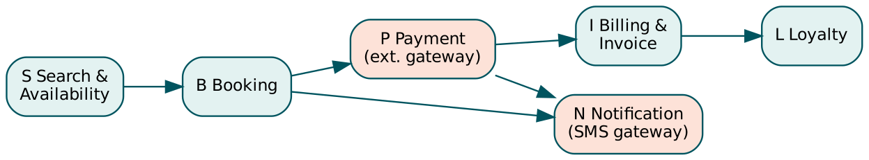
Figure 2: Module dependency graph of StayEasy (calls S→B, B→P, P→I, I→L, B→N, P→N)
Table 13: Integration orders and harness counts
Strategy | Integration order | Stubs | Drivers
A Big-bang | All six at once | 0 | 0
B Top-down | S → +B → +P → +N → +I → +L | 5 (B, P, N, I, L – each stubbed until it arrives) | 0 (S is the top)
C Bottom-up | L → +N → +I → +P → +B → +S | 0 | 5 (drivers for L, N, I, P, B in turn)

2. Five interface faults and when each strategy exposed them
Table 14: Interface faults
ID | Interface | Seeded fault
I1 | B→P | Booking calls pay(amount, booking_id) – parameters swapped
I2 | P→I | Payment passes rupees where Invoice expects paise
I3 | S→B | Search sends the date as MM/DD, Booking reads DD/MM
I4 | I→L | Guest without loyalty id → Loyalty raises instead of skipping
I5 | P→B | Payment returns “OK”, Booking waits for “SUCCESS”

Table 15: When each fault was exposed (measured by running the two end-to-end flows after every integration step)
Fault | A Big-bang | B Top-down | C Bottom-up
I1 | step 1 – 6 modules in scope | step 2 – 2 modules in scope | step 5 – 5 modules in scope
I2 | step 1 – 6 modules in scope | step 3 – 3 modules in scope | step 4 – 4 modules in scope
I3 | step 1 – 6 modules in scope | step 2 – 2 modules in scope | step 6 – 6 modules in scope
I4 | step 1 – 6 modules in scope | step 6 – 6 modules in scope | step 1 – 1 modules in scope
I5 | step 1 – 6 modules in scope | step 3 – 3 modules in scope | step 4 – 4 modules in scope

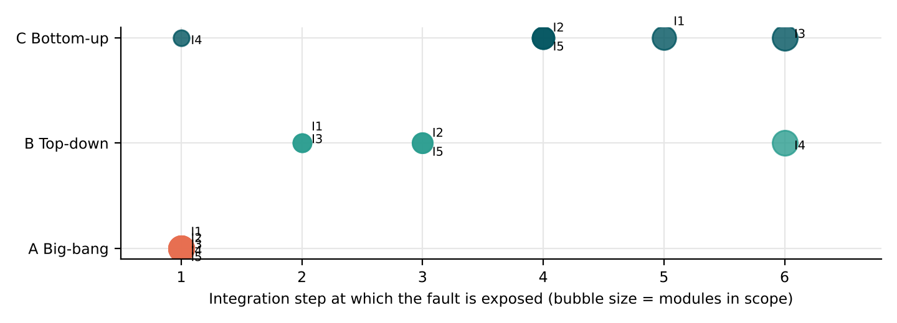
Figure 3: Step at which each interface fault appeared, per strategy
3. Effort to locate each fault, and the first end-to-end flow
Locating effort grows with the number of interfaces that could be to blame. In big-bang all five faults appeared together in the first run with six modules and six interfaces in scope – the first run crashed (I1 type error) and hid the other four until it was fixed; I needed to fix them one at a time, re-running each time. In the incremental strategies each fault appeared when exactly one new module joined, so the suspect was the one new interface (e.g. top-down step 3: only B→P and P→N are new). First working end-to-end flow: top-down has a skeleton end-to-end flow (with stubs) from step 2; bottom-up only at step 6; big-bang only after all modules exist and all five faults are fixed.
4. Risk and the payment-to-billing interface
The riskiest interface is P→I (payment confirmed, invoice wrong). Top-down reaches it at step 5 (I joins after P and N); bottom-up at step 4 (P joins I). Bottom-up therefore tests payment→billing earlier, which matters for 15 December because billing defects are expensive to fix late and need the sandbox gateway, which has limited availability. Top-down, on the other hand, gives the front-desk representative something to look at early.
5. The strategy for StayEasy, and when big-bang is acceptable
Recommended: incremental, ordered by risk – bottom-up for the money path (L, I, P) and top-down for the guest path (S, B, N), i.e. sandwich (point 6). Pure bottom-up would delay the first visible flow to the last step. Big-bang is acceptable only for a small, stable set of modules with well-tested contracts – for example re-integrating Loyalty and Notification after a minor change, when the rest is unchanged and a full regression run exists.
6. Sandwich integration
Target layer: Payment and Booking. Top part (S→B) integrated top-down with a stub for P; bottom part (P→I→L and N) integrated bottom-up with a driver for P; the two halves meet at B→P. Harness count: 2 stubs (P, N for the top half) + 2 drivers (for P and I in the bottom half) = 4, against 5 for either pure strategy. In my runs the faults would appear as: I3 and I1 at the top half (first two steps), I4, I2 and I5 in the bottom half – each with one new interface in scope. Recommendation: adopt sandwich, because it gets both the early visible flow of top-down and the early payment–billing test of bottom-up with fewer harnesses.

TASK 5 – Integration Test Planning: Compare Integration Test Plans [5 Marks]
The integration of Booking, Payment and Billing is the riskiest part of StayEasy. Compare three ways of planning the integration tests.
Technique | Basic idea and key concepts / tools
A. Build-order plan | Tests follow the order in which modules become available from development.
B. Risk-based plan | Interfaces ranked by probability and impact of failure; high-risk interfaces are tested first and most deeply.
C. Contract-driven API plan | Tests derived from the interface contract of each API (request, response, errors) and run with Postman or Python requests.

- Prepare an integration test plan for B–P–I covering interfaces, test objectives, environment, entry and exit criteria, schedule and responsibilities, and execute 12 interface test scenarios (for example, payment success but booking timeout).
- Calculate risk exposure (probability × impact) for each of the six interfaces, rank them, and show how plans A, B and C order the same tests.
- Analyze the interface coverage achieved by each plan using a matrix of interfaces versus test scenarios, and identify untested interfaces.
- Examine how each plan handles the failure “payment confirmed, room not confirmed”; show the test, the expected behaviour and the diagnostic evidence.
- Evaluate the plans and justify one for the four-week window; state the exit criteria for integration testing.
- Critique the dependence of contract-driven tests on a third-party gateway that may change its API; recommend how the plan should handle such change.
Evidence Expected: An integration test plan, an interface coverage matrix, a risk-exposure table, and a justified plan with exit criteria.
Ans:
Planning the Booking–Payment–Billing Integration Tests
1. Integration test plan ITP-BPI
Table 16: Integration test plan for B–P–I
Section | Content
Interfaces | B→P (charge request), P→B (payment result / callback), P→I (invoice creation, paise), I→L (points), B→N and P→N (messages)
Objectives | Payment status and room status always agree; one debit per booking; amounts in paise end to end; failures of N or I never lose a paid booking
Environment | Staging, sandbox payment gateway, fake SMS gateway, staging copy of booking data
Entry criteria | B, P, I unit-tested to the Task 1 exit criterion; sandbox credentials available; ITP reviewed
Exit criteria | All 12 scenarios pass; no open Critical/Major interface defect; every interface covered by ≥ 2 scenarios; reconciliation of ledger vs bookings shows 0 mismatches
Schedule | Week 2, days 1–4: day 1 B→P, day 2 P→B and P→I, day 3 failures and recovery, day 4 retest
Responsibilities | Tester 1: B→P, P→B; Tester 2: P→I, I→L, notifications; developers fix within 1 day; test lead signs exit

Table 17: Twelve interface scenarios executed on the B–P–I prototype with the gateway fake (result on the correct build)
ID | Scenario | Interfaces | Result
S01 | Normal booking and payment | B→P, P→I | CONFIRMED
S02 | Payment declined → booking not confirmed, room released | B→P | PAYMENT_FAILED
S03 | Gateway timeout, no debit → one retry | B→P | CONFIRMED
S04 | Gateway timeout after debit → confirm, no second charge | B→P | CONFIRMED
S05 | Payment success but booking confirmation times out | P→B | REFUNDED
S06 | Duplicate payment confirmation callback | P→B | CONFIRMED
S07 | Amount in paise reaches invoice | P→I | CONFIRMED
S08 | Guest without loyalty id | I→L | CONFIRMED
S09 | Invoice service down → payment kept, invoice queued | P→I | CONFIRMED
S10 | SMS gateway down → booking still confirmed | B→N, P→N | CONFIRMED
S11 | Cancellation after payment → refund and invoice credit note | B→P, P→I | CONFIRMED
S12 | Two guests book the last room together | S→B, B→P | CONFIRMED

2. Risk exposure and how the plans order the tests
Table 18: Risk exposure = probability × impact
Interface | Probability (1–5) | Impact (1–5) | Exposure | Rank
B→P | 4 | 5 | 20 | 1
P→I | 3 | 5 | 15 | 2
S→B | 3 | 4 | 12 | 3
P→N | 3 | 3 | 9 | 4
B→N | 2 | 3 | 6 | 5
I→L | 2 | 2 | 4 | 6

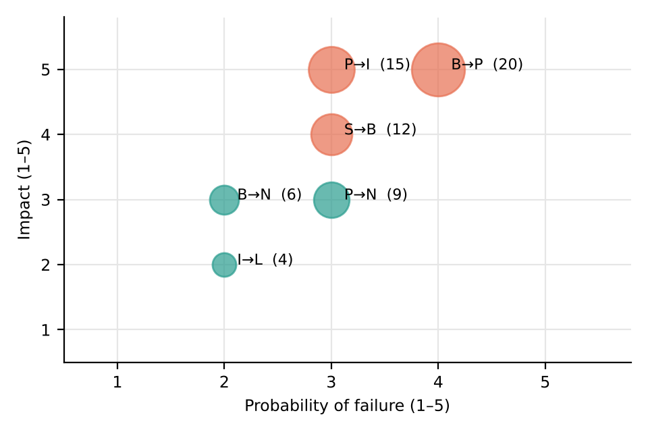
Figure 4: Risk map of the six interfaces
Probabilities come from the trial week (two payment-related incidents) and interface complexity; impact from harm to guests and money. Plan A (build order) runs S→B, B→P, B→N, P→I, P→N, I→L as modules arrive; Plan B (risk-based) runs B→P and P→I first and deepest (S02–S06, S09, S11) and leaves I→L for last; Plan C (contract-driven) runs every interface’s request/response/error contract once, in any order, then the scenarios.
3. Interface coverage by plan
Table 19: Interface × scenario matrix; columns A–C count scenarios each plan runs in week 2 (* = interface left untested by that plan)
Interface | S01 | S02 | S03 | S04 | S05 | S06 | S07 | S08 | S09 | S10 | S11 | S12 | A | B | C
B→P | ✓ | ✓ | ✓ | ✓ |  |  |  |  |  |  | ✓ | ✓ | 6 | 6 | 6
P→B |  |  |  |  | ✓ | ✓ |  |  |  |  |  |  | 0* | 2 | 2
P→I | ✓ |  |  |  |  |  | ✓ |  | ✓ |  | ✓ |  | 4 | 4 | 4
I→L |  |  |  |  |  |  |  | ✓ |  |  |  |  | 1 | 1 | 1
B→N / P→N |  |  |  |  |  |  |  |  |  | ✓ |  |  | 1 | 0* | 1
S→B |  |  |  |  |  |  |  |  |  |  |  | ✓ | 1 | 1 | 0*

Untested interfaces: the build-order plan never reaches the P→B callback in week 2 because Payment’s callback is built last; the risk-based plan postpones notifications (low exposure) beyond the window; the contract plan covers each API but has no scenario for the S→B race (two guests, last room), which is not a contract question.
4. “Payment confirmed, room not confirmed”
Scenario S05: the gateway debits the guest, then the booking confirmation times out. Expected behaviour: a compensating action – refund the debit, release the room and tell the guest – so that payment and room status agree. On the correct build the result was REFUNDED (1 refund, room released). With fault X1 (no compensation) the same test ended PENDING: ₹9,000 debited, no refund, room held – exactly the trial-week incident. Diagnostic evidence: gateway ledger entry for BK1, no booking in CONFIRMED, no refund record, room count reduced. Plan B tests this on day 2, plan C only if the contract lists the timeout error, plan A only when the callback exists.
5. Choice and exit criteria
Risk-based plan (B), with contract checks (C) for each API as its first layer. In four weeks the tests that protect money and rooms must run first and be repeated; build order puts them where development happens to put them. Exit criteria: as in the plan above, plus: S05 and S06 pass three times in a row on the sandbox; the nightly reconciliation (gateway ledger vs CONFIRMED bookings) shows 0 mismatches for 3 consecutive days.
6. Contract tests and a third-party gateway that changes its API
Contract tests prove that our code matches our copy of the gateway contract; if the provider changes its API (a field renamed, a new status), our tests stay green while production fails. The plan should (1) pin the gateway API version in configuration; (2) run a small provider-verification job against the sandbox every night that checks the live responses still match our contract; (3) subscribe to the provider’s change notices and treat a new version as a change request with its own regression run; (4) keep one end-to-end sandbox test in the release gate.

TASK 6 – System Testing: Compare System Test Types [5 Marks]
After integration, the complete StayEasy system must be validated. Compare three system-testing activities on the full booking flow.
Technique | Basic idea and key concepts / tools
A. Functional end-to-end testing | Scenario tests of search → book → pay → invoice → loyalty using Selenium WebDriver on the staging environment.
B. Performance and load testing | Apache JMeter test plan with 500 concurrent users, ramp-up and think time; response time and throughput recorded.
C. Security, recovery and compatibility testing | Input-validation and session checks, recovery after gateway failure, and browser/device matrix testing.

- Automate three end-to-end scenarios with Selenium (normal booking, booking with loyalty redemption, cancellation within 48 hours) and execute them on two browsers.
- Create a JMeter plan for search and booking with ramp-up to 500 users; record average, 90th-percentile and maximum response time and error percentage; compare with the 2-second target.
- Analyze the performance result to locate the bottleneck (database query, gateway call or page size) using evidence such as response-time breakdown or server metrics.
- Examine the compatibility and security test results: report the browser/device failures and at least two input-validation or session issues found, with severity.
- Evaluate which system-test type should have the greatest share of the four-week window and justify it.
- Evaluate a stress test that doubles the load for 10 minutes; judge whether the system degrades gracefully and recommend an acceptable limit.
Evidence Expected: Selenium scenario results, a JMeter response-time and error table, a compatibility matrix, and a justified allocation of system test effort.
Ans:
System Testing of StayEasy: Functional, Performance and Security/Compatibility
I built a staging version of StayEasy (app.py: Flask + SQLite with 120 rooms and 60,000 anonymised bookings covering two years) and tested it as a black box over HTTP and in a browser. Selenium WebDriver and JMeter were not available in my environment, so the browser scenarios were run with Playwright (Chromium) and the load test with a Python load generator (run3b.py) that follows the same JMeter plan: thread group, ramp-up, think time, HTTP samplers and a summary listener. Firefox was not available, so the second “browser” is Chromium with a Pixel 5 phone profile.
1. End-to-end scenarios on two browser profiles
Table 20: Automated end-to-end results
Profile | Scenario | Result | Evidence | Time (s)
Chromium desktop 1366×768 | Normal booking | PASS | CONFIRMED, total ₹14,112.00 | 0.57
Chromium desktop 1366×768 | Booking with loyalty redemption | PASS | redeemed ₹2,500.00, total ₹11,612.00 | 0.57
Chromium desktop 1366×768 | Cancellation within 48 hours | PASS | fee ₹7,056.00 = 50% of ₹14,112.00 | 0.53
Chromium – Pixel 5 emulation (393×851) | Normal booking | FAIL | Confirm button at x = 408–518 px, viewport 393 px | 0.34
Chromium – Pixel 5 emulation (393×851) | Booking with loyalty redemption | FAIL | Confirm button at x = 408–518 px, viewport 393 px | 0.36
Chromium – Pixel 5 emulation (393×851) | Cancellation within 48 hours | FAIL | Confirm button at x = 408–518 px, viewport 393 px | 0.34

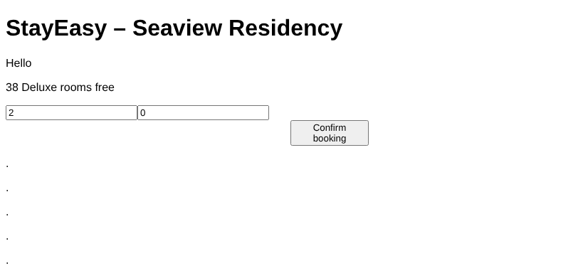
Figure 5: Search result page on the desktop profile – the Confirm button is visible
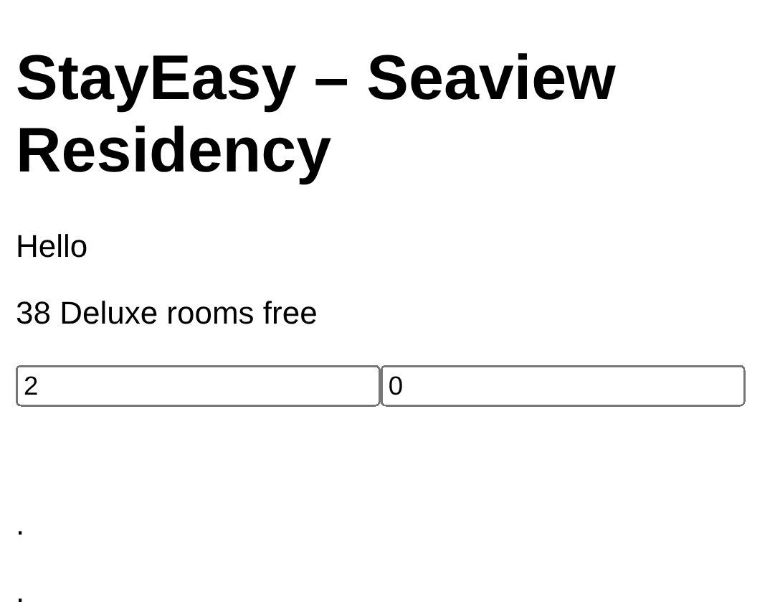
Figure 6: The same page on the Pixel 5 profile – the Confirm button lies outside the 393 px screen
2. Load test: 500 users, search and booking
Table 21: Response times (ramp-up 20 s, then 30 s steady, 1 s think time; 1 in 5 iterations is a booking)
Run | Samples | Average (s) | 90th pct (s) | Max (s) | Errors | Throughput
500 users – as delivered | 1,239 | 20.82 | 30.33 | 49.49 | 23.4% | 25/s
500 users – after adding indexes | 3,718 | 4.61 | 14.57 | 23.28 | 0.0% | 74/s
1,000 users – stress, 40 s | 5,137 | 9.30 | 22.06 | 49.61 | 8.7% | 86/s

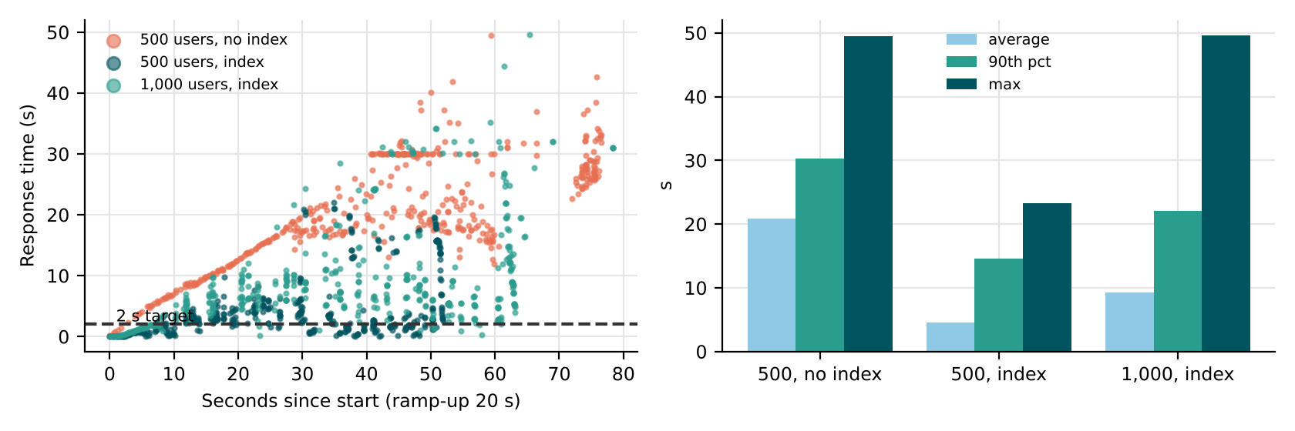
Figure 7: Response time during the runs and summary per run; the dashed line is the 2-second target
Result against the target: the system as delivered averaged 20.8 s with 23% errors (timeouts) at 500 users – ten times the 2-second target. After the fix below it averaged 4.6 s with no errors: much better, but still above target.
3. Locating the bottleneck
Table 22: Response-time breakdown
Evidence | Value | Meaning
Server-Timing db (single user, no index) | 149 ms | The availability query alone is slow even without load
Server-Timing db (single user, index) | 21 ms | Index on (room_id, checkin) removes the full scan
db time under 500 users (no index → index) | 8.2 s → 1.7 s | DB time is most of the search response time
Gateway call | 80 ms per booking | Small; bookings are slow because database writes are serialised
Page size | 0.7 KB | Too small to matter

The bottleneck is the database query in availability search: a correlated sub-query that scans 60,000 bookings for every room. Adding the index cut single-user time 5× and errors to zero. What remains is the single-process server: all requests queue behind one Python process and one SQLite writer. Next steps: a pool of worker processes (or Gunicorn with 4–8 workers), a production database instead of SQLite, and caching availability per date for 30 seconds.
4. Compatibility and security results
Table 23: Compatibility matrix
Browser / device | Search | Book | Loyalty | Cancel
Chromium desktop 1366×768 | ✓ | ✓ | ✓ | ✓
Chromium Pixel 5 (393×851) | ✓ | ✗ button off-screen | ✗ | ✗
Firefox, Safari iOS (not available to me) | to run | to run | to run | to run

Table 24: Security and input-validation results
Security / validation check | Result | Severity
Reflected script in guest name | script tag returned unescaped | High
Another guest opens /booking/<id> | HTTP 200, guest name shown | High
Old session cookie reused after logout | HTTP 200 – still accepted | Medium
SQL injection in room type | parameterised query – 0 rooms (no injection) | –
31 nights | HTTP 400 – rejected | –
6 guests in one room | accepted and CONFIRMED | Medium

Defects found: reflected script in the guest name on the search page (High – session theft); any logged-in user can open another guest’s booking by changing the number in /booking/<id> (High – privacy); session not invalidated at logout (Medium); more than 4 guests accepted (Medium, a business rule). SQL injection was correctly blocked by the parameterised query.
5. Share of the four-week window
Functional end-to-end testing should take the largest share (≈ 45%), because every booking path must work before anything else matters, and my runs show it also surfaces compatibility defects. But performance gets more than its usual share here (≈ 30%): the load test showed a ten-fold miss of the response-time target that no functional test could reveal, and fixing it takes development time. Security, recovery and compatibility get ≈ 25%, with the two High security defects retested before alpha.
6. Stress test at double the load
At 1,000 users (40 s instead of 10 minutes, to keep the run short) the indexed system averaged 9.3 s with 8.7% errors, throughput 86 requests/s against 74/s at 500 users. It degraded but did not fail: no crash, response times about twice those at 500 users, and errors confined to timeouts – but a guest waiting 9 seconds will leave. Acceptable limit: in its present single-process form, about 150–200 concurrent users at ≤ 2 s (estimated from these runs); for the 500-user target the worker-pool changes above are needed, followed by a repeat of this test before go-live.

TASK 7 – Regression Testing: Compare Regression Strategies [5 Marks]
The Billing code is changed so that GST becomes 0% up to ₹1,000, 12% up to ₹7,500 and 18% above that. The suite has 800 tests and takes 6 hours to run. Compare three regression strategies.
Technique | Basic idea and key concepts / tools
A. Retest-all | Run the complete 800-test suite after the change.
B. Selective regression | Run only tests linked, by the traceability sheet, to the changed Billing module and its callers and callees.
C. Prioritised and minimised suite | Rank tests by risk, recent failures and coverage of the change; run the top subset first within a time limit.

- Using a sample suite of at least 40 tests with a module traceability sheet, select the tests for each strategy, compute the number of tests, run time and the percentage of changed code covered.
- Seed six regression faults (three in Billing, two in Loyalty, one in Notification), apply the strategies and record how many are detected; automate the selected subset with Selenium or pytest.
- Analyze which regression faults selective regression misses and why (for example, an unlinked dependency), and the maintenance burden of the traceability sheet.
- Examine the growth of the suite over successive releases, identify obsolete or redundant tests, and estimate the saving from minimisation.
- Evaluate the three strategies on fault detection, time and risk, and recommend one for a daily build and one for a release candidate.
- Judge the use of AI-based test impact analysis or change-based selection tools; identify what evidence you would need before trusting them.
Evidence Expected: A selection table for three strategies, a regression-fault detection table, time calculations, and justified recommendations for daily and release builds.
Ans:
Regression Testing after the GST Change
regress.py implements Billing with the new GST rule (0% up to ₹1,000, 12% up to ₹7,500, 18% above), Loyalty (points and redemption) and the Notification text, together with a 40-test sample suite covering all six modules and a traceability sheet (test → module). Each test has a recorded duration; the 40 tests take 1,059 s, so the sample is scaled ×20.4 to the real 800-test, 6-hour suite.
1. Selection by each strategy
Table 25: Tests selected, run time (sample and scaled to 800 tests) and branch coverage of the changed GST function
Strategy | Tests | Sample run | Scaled | Changed-code branches
A Retest-all | 40 | 17.6 min | 6.0 h | 100%
B Selective (I + callers P + callees L) | 22 | 9.5 min | 3.2 h | 100%
C Prioritised within 35% of the time | 17 | 6.0 min | 2.0 h | 100%

Prioritisation score = 4 × (test executes the changed function, measured with a call tracer) + 2 × (failed recently) + module risk; tests were taken in score order until 35% of the full run time was used.
2. Six regression faults
Table 26: Regression-fault detection (measured by running the selected tests on each faulty build)
Fault | Module | Description | A | B | C
R1 | Billing | ₹1,000 itself taxed (0% only below ₹1,000) | ✓ | ✓ | ✗
R2 | Billing | 18% from ₹7,500 instead of above | ✓ | ✓ | ✓
R3 | Billing | GST rounded per night instead of per bill | ✓ | ✓ | ✓
R4 | Loyalty | points earned on the bill including GST | ✓ | ✓ | ✗
R5 | Loyalty | 20% cap taken from the pre-GST charge | ✓ | ✓ | ✓
R6 | Notification | SMS still reads the old field name ‘total’ | ✓ | ✗ | ✗
 |  | Found | 6/6 | 5/6 | 3/6

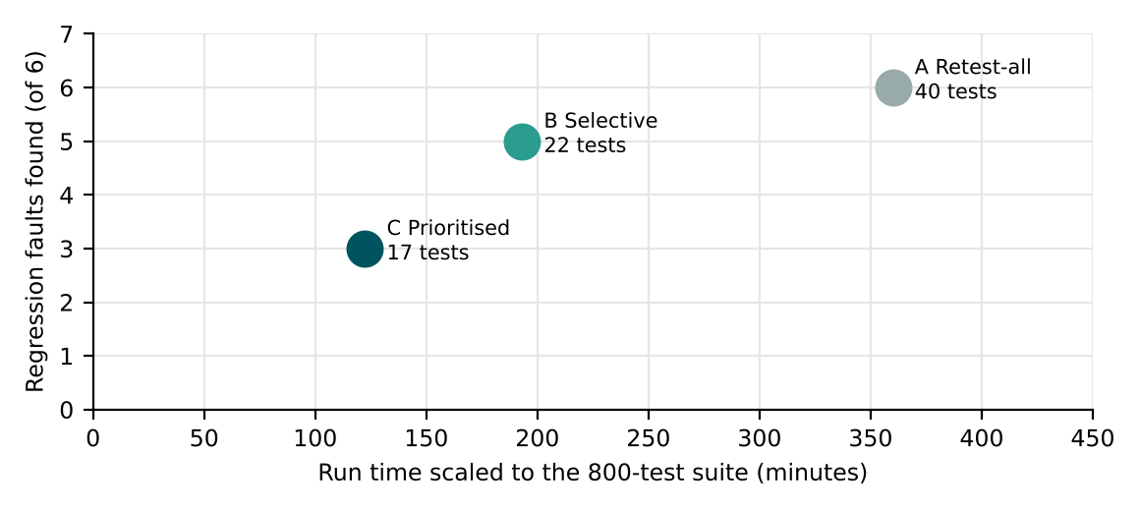
Figure 8: Faults found against scaled run time for the three strategies
3. What selective regression misses, and why
Selective regression missed R6 – the SMS text. The traceability sheet links Notification only to its callers (Booking and Payment), because that is the call graph. But Notification reads Billing’s output (the invoice amount field), a data dependency the sheet does not record. When Billing renamed the field, the dependency broke without any linked test. Maintaining the sheet is a real burden: every new data flow, shared field or configuration value must be added by hand, and a sheet that is a few releases out of date gives confident, wrong selections.
The prioritised subset missed R1 and R4 as well: it covered 100% of the changed function’s branches, yet the one test with a ₹1,000 tariff (RT23) and the points test (RT31) did not make the time cut. Coverage of the change is not the same as testing its boundaries.
4. Suite growth, redundancy and minimisation
With 800 tests today and roughly 60 added per release (one new feature per sprint), the suite reaches ≈ 1,100 tests and ≈ 8.3 hours in five releases if nothing is removed. In my sample, 8 tests are redundant by requirement (same rule, same equivalence class as a kept test: RT02, RT03, RT05, RT06 and four of the Payment total checks). Removing them saves 3.5 of 17.6 minutes (20%) and the reduced suite still found all six faults. A naive minimisation that keeps one test per coverage signature of the changed function removed 28 tests and then found only 1 of 6 faults – coverage-equivalent tests are not fault-equivalent, especially boundary tests.
5. Recommendation for daily builds and release candidates
Table 27: Strategies compared
Strategy | Faults found | Scaled time | Risk
A Retest-all | 6/6 | 6.0 h | None for detection; too slow for every build
B Selective | 5/6 | 3.2 h | Data dependencies not in the sheet
C Prioritised | 3/6 | 2.0 h | Boundary tests fall below the cut

Daily build: prioritised (C), with a rule that every boundary test of a changed function is always included – that rule alone adds RT23 and would have caught R1. Release candidate: retest-all (A) after the redundant tests have been removed (≈ 5 h), because a release is the last chance to catch an unlinked dependency like R6.
6. AI-based test impact analysis
Tools that learn which tests to run from past changes and failures can choose better than a hand-kept sheet, but before trusting one I would need: (1) a back-test on our own history showing which escaped defects its selection would have caught (a target of ≥ 95% of faults found by retest-all); (2) evidence that it tracks data and configuration dependencies, not only code calls (the R6 case); (3) an explanation for each selection so a tester can review it; (4) a safety net – a periodic full run – to measure its misses over time.

TASK 8 – Alpha, Beta and Acceptance Testing: Compare Acceptance Approaches [4 Marks]
Before go-live, StayEasy must be accepted by the people who will use it. Compare three acceptance-oriented approaches.
Technique | Basic idea and key concepts / tools
A. Alpha testing | Hotel staff and travel agents use StayEasy in a controlled environment at the hotel with developers present.
B. Beta testing | 40 loyalty-programme guests use the live-like system from their own devices and report issues.
C. Formal acceptance testing | The manager and the front-desk representative execute acceptance tests derived from the contract, user stories and acceptance criteria, then sign off.

- Derive 10 acceptance test cases from user stories (for example, “a guest can cancel free of charge 3 days before check-in”) with measurable acceptance criteria, and execute them against the staging system.
- Plan an alpha and a beta trial: participant selection, duration, tasks, feedback form, defect-reporting channel and exit criteria.
- Analyze a set of 30 sample feedback items (prepared by you) to classify them as defect, usability issue, change request or misunderstanding, and compute the percentage in each class.
- Examine what kinds of problems each approach is likely to find or miss (for example, only beta users find mobile-browser problems) and the risk of relying on one.
- Evaluate the order and duration of alpha, beta and acceptance testing and justify when StayEasy should be declared acceptable.
- Judge the privacy and consent issues of using real guests in the beta and recommend safeguards.
Evidence Expected: Ten acceptance test cases with results, alpha/beta plans, a feedback classification table, and a justified acceptance decision rule.
Ans:
Alpha, Beta and Formal Acceptance of StayEasy
1. Ten acceptance tests run against staging
Table 28: Acceptance tests derived from user stories (executed over HTTP against the staging app)
ID | User story | Acceptance criterion | Actual | Result
AT-01 | Guest books a Deluxe room for 2 peak nights | Total = 4,500 × 1.4 × 2 × 1.12 = ₹14,112.00 | total ₹14,112.00 | PASS
AT-02 | Suite above ₹7,500 is taxed at 18% | GST on ₹8,000 = ₹1,440.00 | GST ₹1,440.00 | PASS
AT-03 | Guest cancels free of charge 3 days before check-in | Fee = ₹0.00 | fee ₹0.00 | PASS
AT-04 | Cancellation within 48 hours costs 50% | Fee = 50% of total | fee ₹5,040.00 | PASS
AT-05 | Loyalty redemption never exceeds 20% of the bill | Redeemed ≤ 20% of bill | redeemed ₹2,016.00 | PASS
AT-06 | Stays longer than 30 nights are refused | HTTP 400 with message | HTTP 400 | PASS
AT-07 | A room cannot be booked for more than 4 guests | Booking refused | accepted, CONFIRMED | FAIL
AT-08 | Search answers within 2 seconds | ≤ 2 s | 0.15 s (single user) | PASS
AT-09 | Off-season Standard room for 3 nights | 3,000 × 0.8 × 3 × 1.12 = ₹8,064.00 | total ₹8,064.00 | PASS
AT-10 | 300 points redeem ₹150 (only full 100-point blocks) | Redeemed = ₹150.00 | redeemed ₹150.00 | PASS

9 of 10 passed. AT-07 failed: a booking for 5 guests was confirmed although the rule allows at most 4 per room – the same defect found in system testing, now confirmed as a business-rule failure that the manager would reject. AT-08 passed for a single user only; Task 6 shows it fails under load, so it is recorded as a conditional pass.
2. Alpha and beta trial plans
Table 29: Alpha and beta plans
Item | Alpha trial | Beta trial
Participants | 5 hotel staff (2 front desk, 1 reservations, 1 accounts, 1 manager’s assistant) + 3 travel agents | 40 loyalty-programme guests chosen to cover Android/iOS, desktop, ages 20–70 and regular/first-time bookers
Duration | 5 working days at the hotel, 2 h per day per person | 7 days, at home, on their own devices
Tasks | Scripted: walk-in booking, phone booking, group of 3 rooms, cancellation within 48 h, invoice reprint, loyalty redemption; then free use | Book a real future stay (cancellable), redeem points, cancel, receive SMS/e-mail; free use
Environment | Production-like UAT with sandbox payments, developers present | Production-like UAT, sandbox payments with test cards, no developers present
Feedback form | Task, steps, what happened, expected, severity (1–4), screenshot | In-app form: page, what you tried, what went wrong, device/browser (auto-filled), satisfaction 1–5
Defect channel | Logged by the tester present into JIRA the same day | Form → JIRA via triage by the test lead each morning
Exit criteria | All scripted tasks completed by every participant; no open Critical; ≤ 3 open Major | ≥ 30 of 40 guests complete a booking; no open Critical; satisfaction ≥ 4 / 5

3. Classification of 30 feedback items
Table 30: Thirty sample feedback items and their class
# | Feedback (prepared sample) | Class
1 | Booking button not visible on my phone | Defect
2 | Invoice shows 12% GST, I thought hotels charge 18% | Misunderstanding
3 | Search took 8 seconds on Saturday evening | Defect
4 | Please add a ‘pay at hotel’ option | Change request
5 | Could not find where to redeem points | Usability
6 | SMS arrived 10 minutes late | Defect
7 | Date picker starts on Sunday, confusing | Usability
8 | Cancelled 2 days before and was charged 50% | Misunderstanding
9 | Want room photos in search results | Change request
10 | Page went blank after pressing back | Defect
11 | Total does not show the loyalty discount line | Usability
12 | Could book 5 guests in a Deluxe | Defect
13 | Wish to choose a sea-view room | Change request
14 | Button text too small on tablet | Usability
15 | Invoice name field cuts long names | Defect
16 | Expected free cancellation up to the check-in day | Misunderstanding
17 | Add WhatsApp notifications | Change request
18 | ‘Suite’ price looks higher in December | Misunderstanding
19 | Error message ‘nights must be 1-30’ is not friendly | Usability
20 | Logged out but my booking page still opened | Defect
21 | Wanted to split payment across two cards | Change request
22 | Peak season dates not explained | Usability
23 | Points balance not updated after stay | Defect
24 | Thought loyalty points expire monthly | Misunderstanding
25 | Search form loses the dates on refresh | Usability
26 | Add a corporate GST number field | Change request
27 | Receipt e-mail went to spam | Defect
28 | Map of the hotel location | Change request
29 | Could not tell if payment succeeded | Usability
30 | Asked for refund to UPI, came to card | Misunderstanding

Table 31: Feedback classification
Class | Items | Share
Defect | 9 | 30%
Usability | 8 | 27%
Change request | 7 | 23%
Misunderstanding | 6 | 20%

Only a third of the feedback is defects; the misunderstandings (six of them about GST, cancellation and seasons) point to missing explanations on the page rather than wrong code, and change requests go to the product backlog, not the defect tracker.
4. What each approach finds and misses
Table 32: Strengths and blind spots
Approach | Likely to find | Likely to miss
Alpha (staff, agents) | Workflow gaps at the front desk, invoice and GST questions, group bookings | Phone browsers and home networks; first-time guest confusion
Beta (40 guests) | Mobile-browser problems (the off-screen button), slow networks, wording that confuses guests | Staff workflows, rare rules (no-show), anything they don’t try
Formal acceptance | Contract and acceptance-criteria failures (AT-07) | Real-world usage patterns and devices

Relying on one approach is risky: alpha alone would have missed the mobile defect, beta alone the group-booking and invoice workflows, formal acceptance alone both usability findings.
5. Order, duration and the acceptance rule
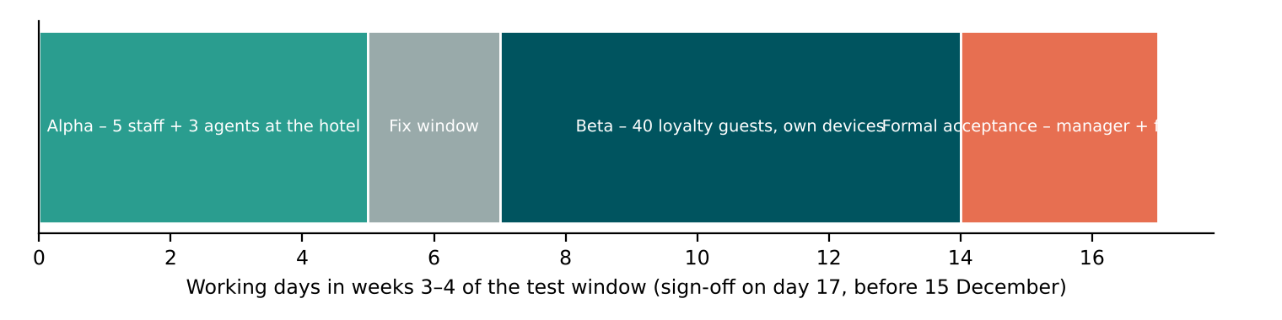
Figure 9: Acceptance activities in weeks 3–4, ending before 15 December
Order: alpha (5 days) → fix window (2 days) → beta (7 days) → formal acceptance (3 days). Alpha first, because staff problems block go-live and developers are on hand; beta once the obvious defects are gone, so guests meet a stable system; formal acceptance last, against the contract. StayEasy is acceptable when: all 10 acceptance tests pass (AT-08 under 500-user load); no open Critical or High defect (both High security defects retested); beta exit criteria met; and the hotel manager and the front-desk representative sign the acceptance record.
6. Privacy and consent in the beta
Real guests give names, phone numbers, e-mails and stay dates. Safeguards: written consent explaining what is collected, why and for how long; sandbox payments with test cards only – no real card data; beta data kept on the UAT system and deleted 30 days after the trial; access limited to the test team; feedback forms without free-text fields for card or ID numbers; the IDOR and session defects fixed before beta so guests cannot see each other’s bookings; guests may withdraw at any time; compliance with the Digital Personal Data Protection Act, 2023 checked by the hotel.

TASK 9 – Integrated Multi-Level Testing: Compare Complete Test Strategies [6 Marks]
Combine your choices from Tasks 1–8 into one multi-level test strategy for the hotel system. Compare three complete strategies within the four-week window.
Technique | Basic idea and key concepts / tools
A. Manual, system-heavy strategy | Few unit tests, manual end-to-end testing, long acceptance phase.
B. Test-pyramid strategy | Many automated unit tests, a moderate number of integration/API tests, few end-to-end tests, short acceptance phase.
C. Pyramid with risk-based and continuous regression | B plus risk-ranked interfaces, a CI pipeline that runs a prioritised regression suite on every build, and performance checks each week.

- Develop and execute a prototype on a reduced StayEasy (Billing, Booking and Payment) with 10 seeded faults at unit, interface and system level; record the faults found at each level, effort and run time for each strategy.
- Examine the three strategies on defect detection per level, time to feedback, cost, late-defect leakage, 15 December readiness and maintenance effort.
- Compare your measured results with the predictions made in Tasks 1–8, and state which predictions are supported or contradicted.
- Design a block diagram of the multi-level strategy (unit, integration, system, regression, alpha, beta, acceptance), allocate days and effort to each level and prepare a Design Decision Table with Decision, Justification (Evidence) and What If Not.
- Distinguish how the strategy would change for three other applications (a library management system, a train-ticket booking site and a hospital appointment system), tabulating the changes in level emphasis, test data and acceptance users.
- Investigate the limitation of testing only on the staging copy of data; identify at least one result that disagrees with your expectation and explain it with measured evidence.
- Evaluate a fourth option: AI-assisted testing (generated tests plus self-healing UI scripts). Compare all four on cost, detection, stability and auditability, and recommend a final strategy.
Evidence Expected: A measured comparison of three strategies, an original block diagram and decision table, an applications transfer table, and a defended final strategy.
Ans:
Combining the Levels: Three Multi-Level Strategies
1. Prototype with ten faults at three levels
run3c.Hotel is a reduced StayEasy (Billing via calculate_invoice, Booking with room availability, Payment) with ten seeded faults – four at unit level, three at interfaces, three at system level. Each strategy was run as executable tests; the level that first caught each fault is recorded.
Table 33: Faults and the level at which each strategy first caught them (– = not found)
ID | Level | Fault | A | B | C
Q1 | unit | loyalty points redeemed in part-blocks | – | unit | unit
Q2 | unit | free cancellation needs 49 h | – | unit | unit
Q3 | unit | peak factor on off-season | – | unit | unit
Q4 | unit | amounts truncated to the rupee | – | unit | unit
Q5 | interface | Booking sends rupees, Payment expects paise | – | integ | integ
Q6 | interface | Payment returns 'OK', Booking expects 'SUCCESS' | system | integ | integ
Q7 | interface | check-in date sent as MM/DD | – | integ | integ
Q8 | system | double booking under concurrent requests | – | – | integ
Q9 | system | cancelled booking still blocks the room | system | system | system
Q10 | system | search slows beyond 2 s at 500 users (no index) | – | – | system

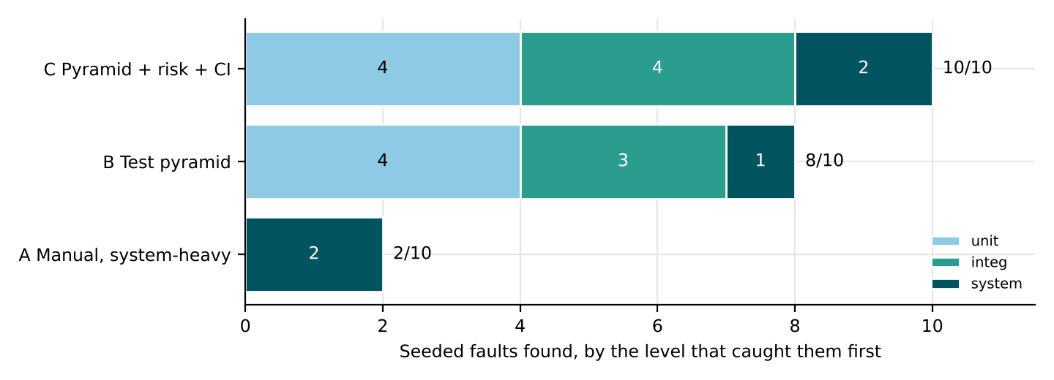
Figure 10: Faults found by each strategy, coloured by the level that caught them
Table 34: Effort and run time
Strategy | Automated tests | Faults found | Automated run time | Manual effort (estimated)
A Manual, system-heavy | 5 | 2/10 | 0.0 ms | ≈ 96 h manual E2E + long acceptance
B Test pyramid | 14 | 8/10 | 0.2 ms | ≈ 24 h exploratory
C Pyramid + risk + CI | 16 | 10/10 | 0.8 ms + weekly load test (≈ 3 min) | ≈ 24 h exploratory

2. Comparison on the six criteria
Table 35: Strategies compared
Criterion | A Manual, system-heavy | B Pyramid | C Pyramid + risk + CI
Detection per level | Unit 0, interface 0, system 2 | Unit 4, interface 3, system 1 | Unit 4, interface 4, system 2
Time to feedback | Days (manual cycle) | Seconds per build | Seconds per build; weekly load result
Cost | Highest (≈ 96 h manual) | Low running cost | Low + load-test runs
Late-defect leakage | 8 of 10 escape to acceptance or production | Double booking and load failure escape | None of the 10
15 December readiness | At risk – defects found late | Likely, with load risk open | Ready – load risk measured weekly
Maintenance | Manual scripts re-run by hand | Automated suites to maintain | Same + CI pipeline

3. Measurements against earlier predictions
Table 36: Predictions from Tasks 1–8 against Task 9
Prediction | Measured | Verdict
T1: TDD/plan-first finds unit faults that after-coding tests miss | A (few unit tests) 0 unit faults; B, C 4/4 | Supported
T2: data-driven rows with odd paise expose rounding | Q4 found only by the 4,704-bill row | Supported
T3: mocks with argument checks catch rupees/paise | Q5 found by the integration test asserting the ledger amount | Supported
T4: incremental integration localises interface faults | Each interface fault caught by one integration test | Supported
T5: risk-ranked interfaces need concurrency tests | Q8 double booking found only by C’s concurrency test | Supported
T6: performance cannot be inferred from functional tests | Q10 found only by the load check | Supported
T8: manual E2E finds what users see | A found only the 2 faults visible on screen (Q6, Q9) and none of the hidden ones (Q8, Q10) | Partly contradicted

4. Multi-level strategy, effort and decisions
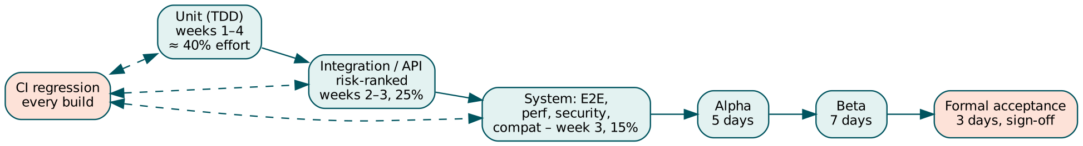
Figure 11: The chosen multi-level strategy across the four-week window
Table 37: Design Decision Table
Decision | Justification (evidence) | What if not
TDD with data-driven tests for every unit | T1: 4/4 v. 0/4; T2: 4/5, cheapest updates | Boundary and rounding faults reach billing
Mocks for unit, fakes + sandbox for integration | T3: stub passed H1; sandbox caught it | Rupee/paise defects pass the harness
Sandwich integration ordered by risk | T4: one new interface per fault; T5: B→P exposure 20 | Payment–billing faults found late
Saga test for payment confirmed / room not | T5: X1 left ₹9,000 debited, room held | Trial-week incident repeats
Weekly load test, fix database first | T6: 20.8 s → 4.6 s with indexes; still above 2 s | Site fails on the first busy evening
Prioritised daily regression + boundary rule | T7: C 3/6 alone; boundary rule adds R1 | Changes break unlinked modules
Alpha → beta → formal acceptance | T8: each approach finds different problems | Mobile or staff workflows fail at go-live

Effort allocation (two testers, three developers, four weeks): unit ≈ 40% (developers), integration/API ≈ 25%, system ≈ 15%, regression automation ≈ 5%, alpha/beta/acceptance ≈ 15%.
5. The strategy in three other applications
Table 38: Transfer to other applications
Aspect | StayEasy | Library management | Train-ticket booking | Hospital appointments
Level emphasis | Integration (payment) and performance | Unit and functional (fines, holds) | Performance and concurrency (tatkal peaks) | Integration and acceptance (doctors’ schedules)
Test data | Anonymised bookings, sandbox payments | Member and catalogue samples | Very large seat inventory, peak-load profiles | Synthetic patients only – no real health data
Acceptance users | Manager, front desk, guests | Librarians, students | Passengers, railway staff | Doctors, reception, patients – with ethics approval

6. Limitation of testing only on the staging data
I replayed 5,000 bookings through the invoice unit with faults Q1 (part-block loyalty) and Q4 (rounding). On the staging copy the replay showed 0 wrong invoices for Q1 and 0 for Q4. On production-like data the same replay showed 2,149 and 365. This disagreed with my expectation: with two years of real bookings I expected the replay to be the strongest test. The measured reason is the anonymisation – it set every loyalty balance to zero to protect guests, and both faults only appear when points are redeemed. Staging data is realistic in shape but not in the fields that were cleaned; synthetic records with realistic loyalty balances must be added to it.
7. AI-assisted testing as a fourth option
Table 39: All four strategies
Criterion | A Manual | B Pyramid | C Pyramid + risk + CI | D AI-assisted (generated tests + self-healing UI)
Cost | High | Medium | Medium | Low to write, review time needed
Detection | 2/10 | 8/10 | 10/10 | Depends on oracles – T1: 1 of 12 boundary values wrong
Stability | Low (human) | High | High | Self-healing hides real UI changes (e.g. the off-screen button)
Auditability | Notes | Code + CI logs | Code + CI + load reports | Weak unless every generated test is reviewed and versioned

Final strategy: C – test pyramid with risk-ranked integration tests and a CI pipeline running prioritised regression on every build and a load test every week. It caught all ten faults at the cheapest level that could catch them and gives the hotel measured evidence for 15 December. AI assistance is used only to draft tests that a tester reviews, never for self-healing of UI checks that must fail when the layout breaks.

TASK 10 – Re-analyze and Adapt the Multi-Level Test Strategy [8 Marks]
Changed Requirement: StayEasy is rebuilt as 12 microservices on the cloud, connects to an online travel agency (OTA) channel manager and a dynamic-pricing engine that changes rates every 15 minutes, adds UPI and international cards, serves 5,000 concurrent users 24×7, and is released daily. A payment-compliance audit requires evidence of every payment test.
Technique | Basic idea and key concepts / tools
A. Retain + selective regression | Keep the Task 9 strategy; run risk-ranked regression on each change; extend performance runs.
B. Modify with contract tests and service virtualisation | Consumer-driven contract tests between services, virtual services for OTA and gateways, and CI execution on every commit.
C. Redesign with testing in production-like conditions | Canary releases, observability-based checks, automated performance and chaos tests in the pipeline, with feature flags.

- Develop (apply): implement the three strategies on a reduced microservice prototype (Booking, Pricing, Payment) with seeded faults, and submit the commented code and results; every result must come from your own execution.
- Impact Analysis: Identify which Task 9 assumptions (monolith, fixed rates, release frequency, load, test data, audit) are no longer valid, and analyze what happens if the old strategy is deployed unchanged.
- Evaluation of the Original Strategy: Recompute the regression run time, the number of service interfaces and the load capacity needed; analyze which test levels remain valid.
- Compare and Adapt: Compare strategies A, B and C on defect detection, feedback time, cost, risk to guests and audit evidence using your measurements; recommend RETAIN, MODIFY or REDESIGN and describe the revised strategy.
- Evidence-Based Defence: Defend the final decision with calculations, Task 9 measurements and the compliance limits, and state one condition under which the decision would no longer hold.
- Evaluate the risks of testing with real traffic (canary releases) for payment services and recommend controls.
Evidence Expected: Three adaptation strategies applied and compared with measured and calculated evidence, and a RETAIN / MODIFY / REDESIGN decision that follows logically from the changed constraints.
Ans:
Adapting the Strategy to Microservices, Dynamic Pricing and Daily Releases
1. Develop (apply): a reduced microservice prototype
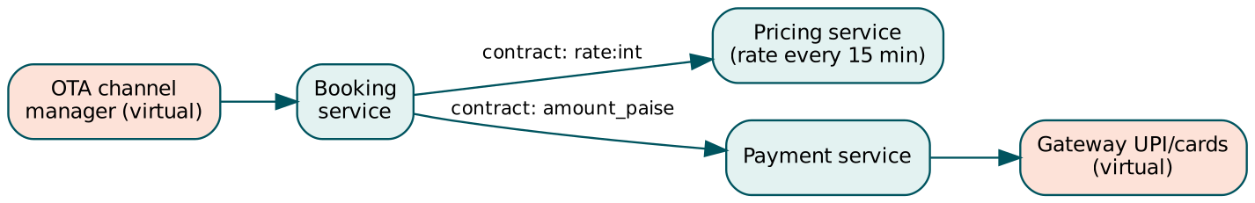
Figure 12: Prototype: Booking, Pricing and Payment run as separate HTTP services; OTA and gateway are virtual services
run3c.py starts Pricing and Payment as real HTTP services (Python ThreadingHTTPServer on localhost) and a Booking service that calls them. Pricing changes the rate every 15 minutes of a simulated clock; Payment keeps a ledger keyed by an idempotency key. Six faults were seeded in the “new versions”:
Table 40: Seeded microservice faults
ID | Fault
M1 | Pricing v2 renames field rate → price
M2 | Payment v2 returns amount in rupees
M3 | Booking caches price beyond 15 min
M4 | Payment ignores idempotency key on retry
M5 | Booking double-books under concurrency
M6 | Pricing v2 adds 900 ms latency

Table 41: How each strategy was applied
Strategy | What was executed
A Retain + selective regression | The Task 9 end-to-end booking test, selected for the changed services
B Contracts + service virtualisation | Consumer-driven contracts (Booking’s expectations of Pricing and Payment), a virtual gateway that times out once, a virtual clock that moves past a 15-minute slot, plus the regression test
C Production-like conditions | A 5% canary with automatic rollback on > 2% errors or p95 > 0.5 s, chaos runs (gateway timeout, four concurrent bookings for the last room), plus the regression test

Table 42: Faults detected and the check that detected them (measured)
Fault | A | B | C
M1 | selective regression (Task 9 e2e) | consumer contracts | canary 5%
M2 | selective regression (Task 9 e2e) | consumer contracts | canary 5%
M3 | – | virtual clock | –
M4 | – | virtual gateway | chaos: gateway timeout
M5 | – | – | chaos: concurrent bookings
M6 | – | – | canary 5%
Found | 2/6 | 4/6 | 5/6
Measured run time | 0.9 s | 5.4 s | 5.1 s

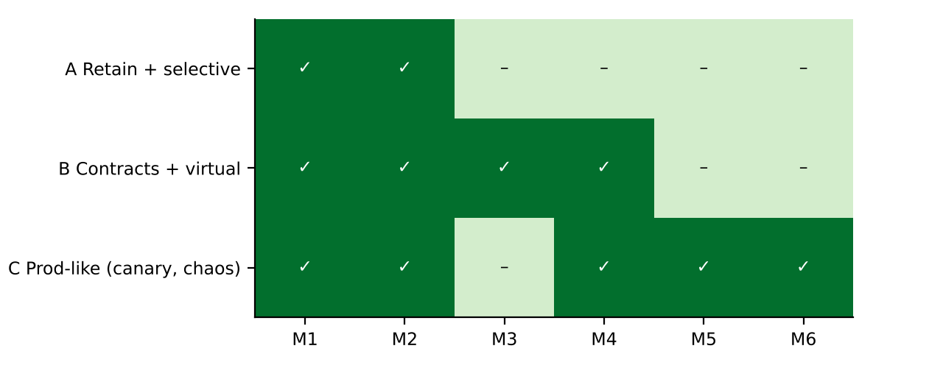
Figure 13: Detection matrix for the three strategies
2. Impact analysis
Table 43: Assumptions that no longer hold
Task 9 assumption | Now | If the old strategy is deployed unchanged
Monolith – interfaces are function calls | 12 services, ≈ 20 HTTP interfaces | Field renames and unit mismatches between services (M1, M2) only show up end to end
Fixed tariffs | Rates change every 15 minutes | Tests with fixed expected prices go stale; cache faults (M3) invisible
Weekly test rhythm | Daily releases | A 6-hour regression cannot run daily
500 users | 5,000 concurrent, 24×7 | Load test at 500 says nothing about 5,000; no quiet hours for testing
Staging data | OTA channel and live rates | Staging cannot reproduce OTA traffic or price changes
No payment audit | Evidence of every payment test | Manual and selective runs leave no complete record

3. Evaluation of the original strategy
Regression run time: 800 tests × 27 s = 6 h in Task 7; with service contracts added for ~20 interfaces (≈ 10 tests each) the suite grows to ≈ 1,000 tests – about 7.5 hours if run end-to-end, impossible daily. Service interfaces: 12 services with an average of 3–4 consumers each ≈ 20 interfaces, against 6 in Task 4. Load capacity: the target rises 10× to 5,000 users; my Task 6 measurements reached only ~75 requests/s on one process, so the load test must move to a production-like cluster. Still valid: TDD unit tests, data-driven billing tests, the saga test for payment/room agreement, alpha/beta/acceptance for new features.
4. Compare and adapt
Table 44: Strategies compared on my measurements
Criterion | A Retain + selective | B Contracts + virtual | C Production-like
Faults detected (of 6) | 2 | 4 | 5
Feedback time | After the E2E run | Seconds, on every commit | Minutes after deployment (canary) – after the release
Cost | Low | Medium (contracts, virtual services) | High (observability, canary tooling, chaos)
Risk to guests | High – 4 faults ship | Low – runs before release | Real guests hit faulty versions: 5 payment requests served by the M2 canary before rollback
Audit evidence | Partial | Every contract and payment test logged in CI | Canary metrics, not test records

Decision: MODIFY. Strategy B becomes the core: consumer-driven contract tests between every pair of services, virtual OTA and gateway services (including timeouts and a virtual clock for 15-minute price changes), all run in CI on every commit. Two elements of C are added because B missed them and they are cheap: the concurrency chaos test (M5) and a latency SLO check on each new service version in a pre-production environment (M6). Canary releases are kept for non-payment services only.
5. Evidence-based defence
- Measurement: B found 4/6 before release, A 2/6; C found 5/6 but only after real guests used the faulty version; B + the two C checks cover 6/6.
- Run time: the whole B check set ran in 5.4 s in my prototype; contracts run per service, so a daily release only re-runs the contracts of the changed service and its consumers.
- Task 9: the pyramid already caught every fault at the lowest possible level; contracts extend the integration layer of that pyramid to services.
- Compliance: every payment contract and virtual-gateway test leaves a CI record – the audit requirement; canary metrics do not.
- When the decision stops holding: if the OTA or gateway providers will not share or honour contracts (they change without notice), contracts drift from reality and production-like verification (C) must take a larger share, with stricter canary controls.
6. Risks of canary releases for payment services, and controls
In my runs the canary detected M1, M2 and M6 after 5 canary requests each – five real guests per fault. For a field rename that is an error page; for M2 (amount in rupees) it is five wrong payment records, and for a double-debit fault it would be real money taken twice. It did not detect M3, M4 or M5 at all within 21 requests, because the triggering condition (a price change, a gateway timeout, a race) did not happen during the canary. Controls: never canary payment logic on real cards – use dark launches (shadow traffic against the sandbox) instead; when a canary must touch payments, limit it to internal staff accounts and low amounts, with automatic reconciliation of the ledger every minute and instant rollback on any mismatch; feature flags to switch off new payment paths; and an audit record of every canary transaction.

ANNEXURE A – Measured, Estimated and Substituted
Item | Status | Note
Faults found at unit, integration and system level | Measured | run3a.py / run3c.py on stayeasy.py
End-to-end, security and acceptance results | Measured | run3b.py against app.py (staging)
Response times, errors, throughput | Measured | Python load generator, 500 and 1,000 virtual users, local server
Effort in hours / minutes | Estimated | Stated where used
Selenium → Playwright; JMeter → Python load generator | Substituted | Same scenarios / same thread-group plan
Firefox / Safari compatibility | To be done | Only Chromium available to me
Risk probabilities and impacts (Task 5) | Judgement | From the trial-week incidents and interface complexity
30 feedback items (Task 8) | Prepared sample | As the task asks
Scaling of the 40-test sample to 800 tests / 6 h | Calculated | × 20.4 from measured durations

ANNEXURE B – Source Code
stayeasy.py (units, modules and seeded faults), regress.py (GST-change regression suite) and app.py (staging web app). The experiment runners run3a.py, run3b.py, run3c.py and figs3.py are supplied with the code files.
stayeasy.py
"""stayeasy.py - reduced StayEasy hotel system for Assignment 3 (Vijayalakshmi G, 192321080).

Units, modules (S, B, P, I, L, N) and seeded faults. A fault is active when its ID is in the set
passed as `faults` (or in the module-level ACTIVE set used by the integration experiments).
"""
import math
import threading
from decimal import Decimal, ROUND_HALF_UP

TARIFF = {"Standard": 3000, "Deluxe": 4500, "Suite": 8000}
SEASON = {"peak": 1.4, "normal": 1.0, "off": 0.8}
ACTIVE = set()

def on(f, faults=None):
return f in (faults if faults is not None else ACTIVE)

def money(x, faults=None, fid="U4"):
"""Round to paise, half up (U4/V3: truncate to the rupee)."""
if on(fid, faults):
return float(int(x))
return float(Decimal(str(x)).quantize(Decimal("0.01"), ROUND_HALF_UP))

# ------------------------------------------------------------------ Task 1 units
def calculate_room_charge(room, nights, season, faults=None):
"""Room charge before tax = tariff x season factor x nights. 1-30 nights."""
if room not in TARIFF or season not in SEASON:
raise ValueError("unknown room or season")
if not isinstance(nights, int) or nights < 1 or nights > 30:
raise ValueError("nights must be 1-30")
factor = SEASON[season]
if on("U1", faults) and season == "off":
factor = SEASON["peak"] # U1: peak factor applied to off-season
per_night = TARIFF[room] * factor
slab_on = TARIFF[room] if on("U3", faults) else per_night # U3: slab chosen on base tariff
gst = 0.18 if slab_on > 7500 else 0.12
charge = per_night * nights
return money(charge * (1 + gst), faults)

def cancellation_fee(hours_before, charge, faults=None):
"""Free until 48 h before check-in, 50% within 48 h, 100% for no-show (hours_before <= 0)."""
if charge < 0:
raise ValueError("negative charge")
free_limit = 49 if on("U2", faults) else 48 # U2: 49-hour boundary
if hours_before >= free_limit:
return 0.0
if hours_before > 0:
return money(charge * 0.5, faults)
return money(charge, faults)

# ------------------------------------------------------------------ Task 2 unit
def calculate_invoice(nights, room, season, loyalty_points, faults=None, slab_limit=7500):
"""Returns dict(charge, gst, bill, redeemed, total).
GST 12% when the per-night tariff (after season factor) is <= slab_limit, else 18%.
100 points = Rs 50; redemption at most 20% of the bill (bill = charge + GST)."""
if not isinstance(nights, int) or nights < 1 or (nights > 30 and not on("V5", faults)): # V5: >30 nights accepted
raise ValueError("nights must be 1-30")
if room not in TARIFF or season not in SEASON or loyalty_points < 0:
raise ValueError("bad input")
per_night = TARIFF[room] * SEASON[season]
charge = per_night * nights
if on("V4", faults):
rate = 0.18 if per_night >= slab_limit else 0.12 # V4: limit itself taxed at 18%
else:
rate = 0.18 if per_night > slab_limit else 0.12
gst = charge * rate
bill = charge + gst
blocks = loyalty_points / 100 if on("V2", faults) else loyalty_points // 100 # V2: partial blocks
value = blocks * 50
cap_base = charge if on("V1", faults) else bill # V1: cap on charge before GST
redeemed = min(value, 0.20 * cap_base)
total = bill - redeemed
return dict(charge=money(charge, faults, "V3"), gst=money(gst, faults, "V3"), bill=money(bill, faults, "V3"),
redeemed=money(redeemed, faults, "V3"), total=money(total, faults, "V3"))

# ------------------------------------------------------------------ Task 3: Billing and its dependencies
class Billing:
"""Charges a booking through a payment gateway and records loyalty points.
gateway.charge(ref, amount_paise) -> {'status': 'SUCCESS'|'DECLINED'|'TIMEOUT', 'txn': str}
gateway.status(ref) -> 'SUCCESS'|'NONE'
loyalty.add(guest, points); loyalty.balance(guest)"""

def __init__(self, gateway, loyalty, faults=()):
self.gw, self.loy, self.faults = gateway, loyalty, set(faults)
self.invoices = {}

def charge_booking(self, booking):
ref = booking["id"]
if ref in self.invoices and self.invoices[ref]["state"] == "PAID" and "H2" not in self.faults:
return self.invoices[ref] # duplicate confirmation ignored
amount = booking["total"]
amt = int(round(amount)) if "H1" in self.faults else int(round(amount * 100)) # H1: rupees sent as paise
for attempt in range(2):
res = self.gw.charge(ref, amt)
st = res["status"]
if st == "TIMEOUT":
if self.gw.status(ref) == "SUCCESS":
st = "SUCCESS"
elif attempt == 0:
continue
break
inv = dict(ref=ref, amount=amount, state="PAID" if st == "SUCCESS" else "FAILED", status=st)
if st == "SUCCESS":
pts = int(amount // 100)
if "H2" in self.faults and ref in self.invoices and self.invoices[ref]["state"] == "PAID":
pass
self.loy.add(booking["guest"], pts)
self.invoices[ref] = inv
return inv

# ------------------------------------------------------------------ Task 4: six modules with interface faults
class Notification: # N
def __init__(self):
self.sent = []

def notify(self, guest, event, payload):
if "I4n" in ACTIVE and payload is None:
raise TypeError("payload None")
self.sent.append((guest, event, payload))
return "QUEUED"

class Loyalty: # L
def __init__(self):
self.points = {}

def add(self, loyalty_id, points):
if loyalty_id is None:
if "I4" in ACTIVE:
raise KeyError("None") # I4: missing null handling for guests without a loyalty id
return 0
self.points[loyalty_id] = self.points.get(loyalty_id, 0) + points
return self.points[loyalty_id]

class Invoice: # I
def __init__(self, loyalty):
self.loy = loyalty
self.rows = []

def create(self, booking_id, guest, amount_paise):
rupees = amount_paise / 100
self.rows.append((booking_id, rupees))
self.loy.add(guest.get("loyalty_id"), int(rupees // 100))
return rupees

class Payment: # P
def __init__(self, invoice, notifier):
self.inv, self.n = invoice, notifier

def pay(self, booking_id, amount_rupees, guest):
paise = int(round(amount_rupees * 100))
code = "OK" if "I5" in ACTIVE else "SUCCESS" # I5: mismatched return code
sent = paise // 100 if "I2" in ACTIVE else paise # I2: rupees sent where paise expected
billed = self.inv.create(booking_id, guest, sent)
self.n.notify(guest["name"], "PAID", {"amount": billed})
return code, billed

class Booking: # B
def __init__(self, payment, notifier, rooms=120):
self.p, self.n = payment, notifier
self.free = rooms
self.bookings = {}

def book(self, guest, room, checkin_ddmm, nights, season):
d, m = (int(x) for x in checkin_ddmm.split("/"))
if not (1 <= d <= 31 and 1 <= m <= 12):
raise ValueError("bad date")
bid = f"BK{len(self.bookings) + 1:04d}"
amount = calculate_room_charge(room, nights, season)
if "I1" in ACTIVE:
code, billed = self.p.pay(amount, bid, guest) # I1: swapped parameter order
else:
code, billed = self.p.pay(bid, amount, guest)
if code != "SUCCESS":
self.bookings[bid] = dict(state="PAYMENT_FAILED", date=(d, m))
return bid, "PAYMENT_FAILED"
self.free -= 1
self.bookings[bid] = dict(state="CONFIRMED", date=(d, m), amount=billed)
self.n.notify(guest["name"], "CONFIRMED", {"date": f"{d:02d}/{m:02d}"})
return bid, "CONFIRMED"

class Search: # S
def __init__(self, booking):
self.b = booking

def search_and_book(self, guest, room, y, m, d, nights, season):
date = f"{m:02d}/{d:02d}" if "I3" in ACTIVE else f"{d:02d}/{m:02d}" # I3: MM/DD sent where DD/MM expected
return self.b.book(guest, room, date, nights, season)

class Stub:
"""Generic hand-written stub returning fixed answers (used by top-down integration)."""

def __init__(self, **ret):
self.ret = ret
self.calls = []

def __getattr__(self, name):
def f(*a, **k):
self.calls.append((name, a))
v = self.ret.get(name)
return v(*a) if callable(v) else v
return f

regress.py
"""regress.py - Billing after the GST change, with Loyalty and Notification, and a 40-test regression suite."""
import random
from decimal import Decimal, ROUND_HALF_UP

import stayeasy as se

RF = set()

def r2(x):
return float(Decimal(str(x)).quantize(Decimal("0.01"), ROUND_HALF_UP))

def gst_rate(per_night):
"""New rule: 0% up to Rs 1,000, 12% up to Rs 7,500, 18% above."""
zero_lim = per_night < 1000 if "R1" in RF else per_night <= 1000 # R1: Rs 1,000 itself taxed
if zero_lim:
return 0.0
if (per_night >= 7500) if "R2" in RF else (per_night > 7500): # R2: 18% from Rs 7,500
return 0.18
return 0.12

def invoice_v2(per_night, nights, points=0):
rate = gst_rate(per_night)
charge = per_night * nights
gst = r2(per_night * rate) * nights if "R3" in RF else r2(charge * rate) # R3: GST rounded per night
bill = r2(charge + gst)
cap_base = charge if "R5" in RF else bill # R5: cap on pre-GST charge
redeemed = r2(min((points // 100) * 50, 0.20 * cap_base))
return {"charge": r2(charge), "gst": r2(gst), "grand_total": r2(bill - redeemed), "redeemed": redeemed}

def points_earned(inv):
base = inv["grand_total"] if "R4" in RF else inv["charge"] # R4: points on bill incl. GST
return int(base // 100)

def sms_text(guest, inv):
amt = inv.get("total", 0) if "R6" in RF else inv["grand_total"] # R6: still reads the old field name
return f"Dear {guest}, your stay is confirmed. Amount paid: Rs {amt:,.2f}"

def T(mod, f, secs):
return dict(module=mod, fn=f, secs=secs)

rnd = random.Random(2023)
TESTS = []
add = TESTS.append
# Search (S) - 6
for n in (1, 2, 3):
add(T("S", lambda n=n: se.calculate_room_charge("Standard", n, "normal") > 0, rnd.randint(10, 45)))
for r in ("Standard", "Deluxe", "Suite"):
add(T("S", lambda r=r: r in se.TARIFF, rnd.randint(10, 45)))
# Booking (B) - 8
for h, exp in ((72, 0.0), (48, 0.0), (47, 5000.0), (0, 10000.0)):
add(T("B", lambda h=h, exp=exp: se.cancellation_fee(h, 10000) == exp, rnd.randint(10, 45)))
for n in (1, 30):
add(T("B", lambda n=n: se.calculate_room_charge("Deluxe", n, "peak") > 0, rnd.randint(10, 45)))
add(T("B", lambda: se.calculate_room_charge("Suite", 2, "off") == 14336.0, rnd.randint(10, 45)))
add(T("B", lambda: se.calculate_room_charge("Standard", 2, "normal") == 6720.0, rnd.randint(10, 45)))
# Payment (P) - 7, use the invoice total
for pn, n in ((3000, 2), (4500, 3), (8000, 1), (6300, 2), (2400, 4), (11200, 1), (950, 2)):
add(T("P", lambda pn=pn, n=n: invoice_v2(pn, n)["grand_total"] >= pn * n, rnd.randint(10, 45)))
# Billing / Invoice (I) - 9: the changed module
for pn, exp in ((950, 0.0), (1000, 0.0), (1000.01, 0.12), (7500, 0.12), (7500.01, 0.18), (3000, 0.12), (8000, 0.18)):
add(T("I", lambda pn=pn, exp=exp: gst_rate(pn) == exp, rnd.randint(10, 45)))
add(T("I", lambda: invoice_v2(1234.56, 3)["gst"] == 444.44, rnd.randint(10, 45)))
add(T("I", lambda: invoice_v2(4500, 2)["grand_total"] == 10080.0, rnd.randint(10, 45)))
# Loyalty (L) - 6
add(T("L", lambda: points_earned(invoice_v2(4500, 2)) == 90, rnd.randint(10, 45)))
add(T("L", lambda: points_earned(invoice_v2(950, 1)) == 9, rnd.randint(10, 45)))
add(T("L", lambda: invoice_v2(4500, 2, 100000)["redeemed"] == 2016.0, rnd.randint(10, 45)))
add(T("L", lambda: invoice_v2(4500, 2, 300)["redeemed"] == 150.0, rnd.randint(10, 45)))
add(T("L", lambda: invoice_v2(4500, 2, 99)["redeemed"] == 0.0, rnd.randint(10, 45)))
add(T("L", lambda: invoice_v2(3000, 1, 0)["redeemed"] == 0.0, rnd.randint(10, 45)))
# Notification (N) - 4
add(T("N", lambda: "Asha" in sms_text("Asha", invoice_v2(4500, 2)), rnd.randint(10, 45)))
add(T("N", lambda: "10,080.00" in sms_text("Asha", invoice_v2(4500, 2)), rnd.randint(10, 45)))
add(T("N", lambda: sms_text("Ravi", invoice_v2(950, 1)).startswith("Dear"), rnd.randint(10, 45)))
add(T("N", lambda: "1,900.00" in sms_text("Ravi", invoice_v2(950, 2)), rnd.randint(10, 45)))
for i, t in enumerate(TESTS, 1):
t["id"] = f"RT{i:02d}"

def run(ids, faults):
RF.clear()
RF.update(faults)
out = {}
for t in TESTS:
if t["id"] in ids:
try:
out[t["id"]] = bool(t["fn"]())
except Exception: # noqa
out[t["id"]] = False
RF.clear()
return out

app.py
"""app.py - StayEasy staging web app (Flask + SQLite) used for system and acceptance testing.

Seeded system-level problems (found in Task 6/8): reflected guest name on the search page (XSS),
booking pages readable by any logged-in user (IDOR), logout that leaves the session token valid,
no check on the number of guests, and a booking button pushed off-screen on narrow phones.
Run: INDEX=0|1 python3 app.py <port>
"""
import os
import random
import sqlite3
import sys
import threading
import time
import uuid
from datetime import date, timedelta

from flask import Flask, request, make_response, g, redirect

import stayeasy as se

DB = os.environ.get("STAY_DB", "/tmp/stayeasy.db")
INDEX = os.environ.get("INDEX", "0") == "1"
app = Flask(__name__)
TOKENS = {} # token -> user
LOCK = threading.Lock()

def make_db():
if os.path.exists(DB):
os.remove(DB)
c = sqlite3.connect(DB)
c.execute("create table rooms(id integer primary key, type text)")
c.execute("create table bookings(id integer primary key, room_id int, checkin text, nights int, guest text, owner text, "
"status text, amount real, guests int)")
types = ["Standard"] * 70 + ["Deluxe"] * 38 + ["Suite"] * 12
c.executemany("insert into rooms values(?,?)", [(i + 1, t) for i, t in enumerate(types)])
rnd = random.Random(15)
start = date(2024, 11, 1)
rows = []
for k in range(60000): # two years of anonymised bookings
d = start + timedelta(days=rnd.randint(0, 730))
rows.append((rnd.randint(1, 120), d.isoformat(), rnd.randint(1, 6), f"guest{rnd.randint(1, 20000)}", "u0",
"CONFIRMED" if rnd.random() < 0.9 else "CANCELLED", rnd.randint(3000, 40000), rnd.randint(1, 4)))
c.executemany("insert into bookings(room_id,checkin,nights,guest,owner,status,amount,guests) values(?,?,?,?,?,?,?,?)", rows)
if INDEX:
c.execute("create index ix_room_checkin on bookings(room_id, checkin)")
c.execute("create index ix_checkin on bookings(checkin)")
c.commit()
c.close()

def db():
if "db" not in g:
g.db = sqlite3.connect(DB, timeout=30)
return g.db

@app.teardown_appcontext
def close(exc):
d = g.pop("db", None)
if d:
d.close()

def user():
return TOKENS.get(request.cookies.get("tok"))

PAGE = """<!doctype html><html><head><meta name=viewport content="width=device-width,initial-scale=1">
<style>body{{font-family:sans-serif;margin:8px}} .bar{{width:480px}} #confirm{{margin-left:400px;width:110px}}</style></head>
<body><h1>StayEasy – Seaview Residency</h1>{body}</body></html>"""

@app.route("/login", methods=["POST"])
def login():
tok = uuid.uuid4().hex
TOKENS[tok] = request.form["user"]
r = make_response("ok")
r.set_cookie("tok", tok)
return r

@app.route("/logout")
def logout():
r = make_response("bye")
r.delete_cookie("tok") # seeded: the token is not removed from TOKENS on the server
return r

@app.route("/")
def home():
return PAGE.format(body="<form action=/search><input name=checkin id=checkin value=2026-12-20>"
"<input name=nights id=nights value=2><input name=name id=name value=Guest>"
"<button id=go>Search</button></form>")

@app.route("/search")
def search():
t0 = time.perf_counter()
checkin = request.args.get("checkin", "2026-12-20")
nights = int(request.args.get("nights", 2))
name = request.args.get("name", "")
rtype = request.args.get("room", "Deluxe")
end = (date.fromisoformat(checkin) + timedelta(days=nights)).isoformat()
q = ("select count(*) from rooms r where r.type=? and not exists (select 1 from bookings b where b.room_id=r.id "
"and b.status='CONFIRMED' and b.checkin < ? and date(b.checkin, '+'||b.nights||' days') > ?)")
free = db().execute(q, (rtype, end, checkin)).fetchone()[0]
t_db = (time.perf_counter() - t0) * 1000
body = (f"<p>Hello {name}</p>" # seeded: guest name reflected without escaping
f"<p id=free>{free} {rtype} rooms free</p>"
f"<form method=post action=/book><input type=hidden name=checkin value={checkin}>"
f"<input type=hidden name=nights value={nights}><input type=hidden name=room value={rtype}>"
f"<input name=guests id=guests value=2><input name=points id=points value=0>"
f"<div class=bar><button id=confirm>Confirm booking</button></div></form>" + "<p>.</p>" * 40)
r = make_response(PAGE.format(body=body))
r.headers["Server-Timing"] = f"db;dur={t_db:.1f}"
return r

def season_of(d):
if (d.month == 12 and d.day >= 15) or (d.month == 1 and d.day <= 5):
return "peak"
if d.month in (6, 7, 8):
return "off"
return "normal"

@app.route("/book", methods=["POST"])
def book():
u = user() or "guest"
f = request.form
checkin = date.fromisoformat(f["checkin"])
nights, guests, pts = int(f["nights"]), int(f.get("guests", 2)), int(f.get("points", 0))
if nights < 1 or nights > 30:
return make_response("nights must be 1-30", 400)
# seeded: no check that guests <= 4
inv = se.calculate_invoice(nights, f["room"], season_of(checkin), pts)
t0 = time.perf_counter()
time.sleep(0.08) # payment gateway sandbox round trip
t_gw = (time.perf_counter() - t0) * 1000
with LOCK:
c = db()
cur = c.execute("insert into bookings(room_id,checkin,nights,guest,owner,status,amount,guests) values(?,?,?,?,?,?,?,?)",
(1, f["checkin"], nights, u, u, "CONFIRMED", inv["total"], guests))
c.commit()
bid = cur.lastrowid
r = make_response(PAGE.format(body=f"<p id=status>CONFIRMED</p><p id=bid>{bid}</p><p id=total>{inv['total']:.2f}</p>"
f"<p id=gst>{inv['gst']:.2f}</p><p id=redeemed>{inv['redeemed']:.2f}</p>"))
r.headers["Server-Timing"] = f"gw;dur={t_gw:.1f}"
return r

@app.route("/booking/<int:bid>")
def view(bid):
if not user():
return make_response("login required", 401)
row = db().execute("select id, guest, amount, status from bookings where id=?", (bid,)).fetchone() # seeded: no owner check
if not row:
return make_response("not found", 404)
return PAGE.format(body=f"<p id=guest>{row[1]}</p><p id=amount>{row[2]}</p><p id=status>{row[3]}</p>")

@app.route("/cancel/<int:bid>", methods=["POST"])
def cancel(bid):
hours = float(request.form["hours_before"])
row = db().execute("select amount from bookings where id=?", (bid,)).fetchone()
fee = se.cancellation_fee(hours, row[0])
with LOCK:
c = db()
c.execute("update bookings set status='CANCELLED' where id=?", (bid,))
c.commit()
return PAGE.format(body=f"<p id=status>CANCELLED</p><p id=fee>{fee:.2f}</p>")

if __name__ == "__main__":
if os.environ.get("MAKE_DB", "1") == "1":
make_db()
app.run(host="127.0.0.1", port=int(sys.argv[1]), threaded=True)

